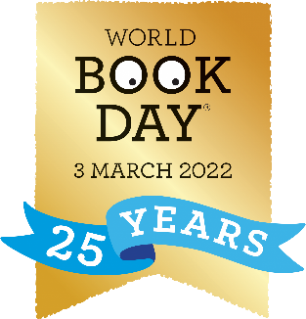

Easy costume ideas for World Book Day

Here are some relatively simple costume ideas that you might be able to put together from things you have at home. If you have the time and access to the materials and want to be more adventurous and creative, the internet is full of ideas you could have a go at with your child.

Many Roald Dahl characters would wear usual children’s clothes, so your child could be James, Charlie or Matilda… A small homemade prop such as a golden ticket can make all the difference to suggesting a character.
Other books also have ordinary children as their main characters including The Christmasaurus, Danger Gang, Horrid Henry or many Enid Blyton books.
A little imagination and careful selection of clothes could turn your child into Fern from Charlotte’s Web, Little Red Riding Hood or Mildred Hubble from the Worst Witch.

With a pair of paper ears or wings, you could make an animal such as a dog, cat, mouse, cow, ladybird or fairy from a book such as Room on the Broom, a Squash and a Squeeze…

If you are able to get hold of some brown paper or cardboard, you could make a Paper Bag Princess or one of the Mr Men or Little Miss. Or perhaps you could make a mask to become a character.
If they are a fan of David Walliams, a pair of pyjamas or a nightie could turn your child into a member of The Midnight Gang, some older style clothes with a mask could create Gangsta Granny or why not become A Boy in a Dress?

Remember, you can use dress up outfits they already have such as princesses, superheroes, pirates or animal onesies.

