Putteridge Primary School

Calculation Policy


January 2022

At Putteridge Primary, we are using ‘White Rose Maths’ and ‘Herts Essentials’ format as a basis for our planning. We are using this alongside other tools that are already in place for the teaching of maths. This structure and sequences are adapted to meet the needs of the children at Putteridge Primary School. We are using the White Rose/Herts Essentials philosophy of:
- Fluency
- Reasoning
- Problem solving

In our maths work we are using a Concrete, Pictorial and Abstract approach (CPA).
Concrete are objects that can be touched and moved by pupils to introduce, explore or reinforce a mathematical concept.
Pictorial is when you take the concrete experience and translate it into a pictorial representation. This helps to focus attention on what has happened and why.
Abstract is ‘symbolic’ stage, where children are able to use abstract symbols to model and solve maths problems. Once a child has demonstrated that they have a solid understanding of the ‘concrete’ and ‘pictorial’ representations of the problem, the teacher can introduce the more ‘abstract’ concept, such as mathematical symbols. Children are introduced to the concept at a symbolic level, using only numbers, notation, and mathematical symbols, for example +, –, x, / to indicate addition, multiplication, or division
The aim is that when children leave Putteridge Primary they:
- Have a secure knowledge of number facts and a good understanding of the four calculation operations (addition, subtraction, multiplication and division)
- Make use of jottings, diagrams and informal notes to help record steps and part answers when using mental methods that generate more information than can be kept in their heads
- Have an efficient, reliable, written method of calculation for each operation that they are able to apply with confidence when they are unable to perform a calculation mentally

Foundation Stage
Addition
Key Skills for addition  - Select the correct numeral to represent 1 to 5, then 1 to 10 objects.  - Count an irregular arrangement of up to ten objects.  - Estimate how many objects they can see and check by counting.  - Use language of ‘more’ and ‘fewer’ to compare two sets of objects.  - Join two groups of objects together to find the total.  - Say the number that is one more than a given number.  - Find one more from a group of up to five objects, then ten objects.  - Count on from a given number.  - In practical activities and discussion, begin to use the vocabulary involved in addition.  - Record using marks that they can interpret and explain.  - Begin to identify own mathematical problems based on own interests and fascinations. | Vocabulary  Add makes biggest  More altogether after  Count order one more  Count on bigger next  Largest plus double  How many more to make?  How many more is…than…?
Written Methods and Skills
- Have an understanding of what “more” means and be able to say what is one more than a given number.  - Children begin to combine groups of objects or pictures and use concrete apparatus.  - Solve simple problems using fingers and introduce Numicon when appropriate.  - Children make a record in pictures, words, Numicon shapes or symbols of addition activities already carried out.  - Children are encouraged to read number sentences aloud in different ways:  e.g. “Three add two equals 5” “Four plus 3 makes 7”  - Construct number sentences verbally, or by using cards to go with practical activities.  - Number lines can be used alongside practical apparatus to solve addition calculations and word problems. Children “jump” along the number line to “count on”. |  |   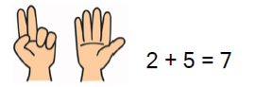  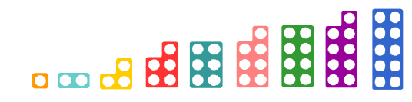  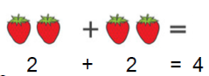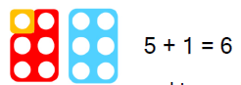  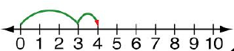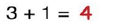

Year 1
Addition
Mental methods and skills  - Number pairs with a total of 20 e.g. 13+7 or what to add to a single digit number to make 10, e.g. 3 + = 10  - Addition facts for totals to at least 5, e.g. 2+3, 4+3  - Addition doubles for all numbers to at least 10, e.g. 8+8  - Add a pair of single digit numbers, e.g. 4+5  - Add a single digit number to a teens number e.g. 13+5  - Add a single digit to or from 10 and add a multiple of 10 to a single digit number e.g. 10+7, 7+30  - Add near doubles e.g. 6+7  - Reorder numbers when adding e.g. put the larger numbers first  - Count on in ones, twos or tens from largest number.  - Partition small numbers e.g. 8+3=8+2+1  - Partition and combine tens and ones  - Partition double and adjust, e.g. 5+6=5+5+1  - Number bonds and related – facts within 20  - Empty box questions: 3 + = 7 + 4 = 7 |  |  | Vocabulary  Combine Number Sentence Partition  Pairs Doubles Empty box  Total Multiple Largest  Digit Near double Operation  Sum Increase More  Ten more Ten less numeral  Figure order value  Between number bonds number line  Add make plus  Sum altogether inverse  Equal is the same as
Written Methods and Skills
Objective and Strategy  Combining two parts to make a whole: part- whole model | Concrete  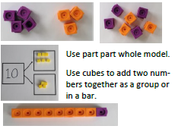 | Pictorial  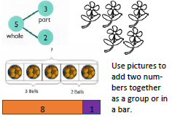 |  | Abstract  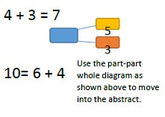  S+S=B
 | Start with the larger number on the bead string and then count on to the smaller number 1 by 1 to find the answer. | 12 + 5 = 17
  Starting at the bigger number and counting on
  5 + 12 = 17
  Place the larger number in your head and count on the smaller number to find your answer.
Regrouping to make 10.  This is an essential skill for column addition later. | 6 + 5 = 11  Start with the bigger number and use the smaller number to make 10. | Use pictures or a number line. Regroup or partition the smaller number to make 10. |  | 7 + 4= 11  If I am at seven, how many more do I need to make 10? How many more do I add on now?
Represent & use number bonds and related subtraction facts within 20 | 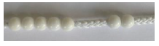  2 more than 5. | 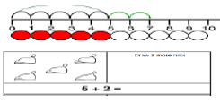 |  | Emphasis should be on the language  ‘1 more than 5 is equal to 6.’  ‘2 more than 5 is 7.’  ‘8 is 3 more than 5.’

Year 2
Addition
- Number pairs with totals to 20  - All pairs of multiples of 10 with totals of up to 100 e.g. 30+70, or 60+ = 100  - What must be added to any two digit number to make the next multiple of 10 e.g. 52+ =60  - Addition doubles for all numbers to 20 e.g. 17+17 and multiples of 10 to 50 e.g. 40+40  - Add a pair of single digit numbers, including crossing 10, e.g. 5+8  - Add any single digit number to a multiple of 10, e.g. 60+5  - Add a single digit number to or from a two-digit number, including cross the tens boundary, e.g. 23+5 then 28+5  - Add a multiple of 10 to any two digit number, e.g. 27+60  - Add 9,19,29… or 11,21,31 …  - Add near doubles e.g. 13+14, 39+40  - Partition: bridge through 10 and multiples of 10 when adding  - Partition and combine multiples of tens and ones  - Partition: count on in tens and ones to find the total  - Add two 2 digit numbers |  |  | Vocabulary  Crossing tens boundary  Bridge through tens  Inverse  Place Value  Greater than  Partition  More  Recombine  hundreds
Written Methods and Skills
Objective and Strategy  Adding mutliples of 10 | Concrete  50= 30 = 20  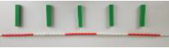  Model using dienes and bead strings | Pictorial  Use representations for base ten. |  | Abstract  20 + 30 = 50  70 = 50 + 20  40 + □ = 60
Use know number facts part whole model | 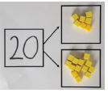  Children explore ways of making numbers within 20 | 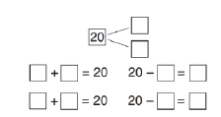 |  | 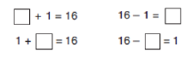  S+S=B  S S B  + 15=31
Using known facts | 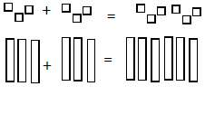 | 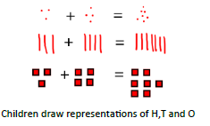 |  | 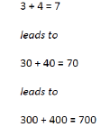
Bar model | 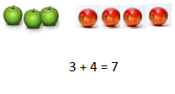 | 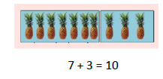 |  | 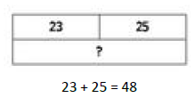
Add a two digit number and ones | 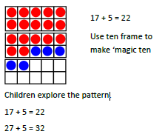 | 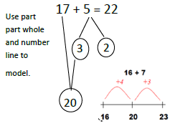 |  | 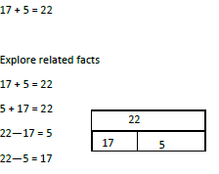
Add a 2 digit number and tens | 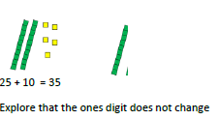 | 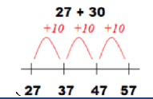 |  | 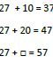
Add two 2-digit numbers | 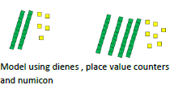 | 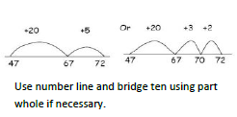 |  | 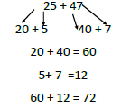  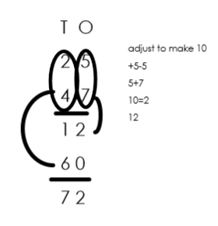
Add three 1-digit numbers | 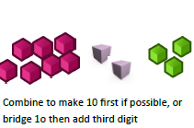 | 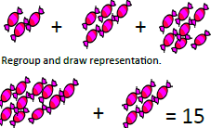 |  | 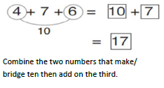

Year 3
Addition
Mental methods and skills  - Pairs of two-digit numbers with a total of 100, e.g. 32 + 68, or 32 + = 100.  - Addition doubles for multiples of 10 to 100, e.g. 90 + 90.  - Add groups of small numbers, e.g. 15 + 3 + 2.  - Add two-digit numbers e.g. 34 + 65.  - Add near doubles, e.g. 18 + 16, 60 + 70.  - Partition: add tens and ones separately, then re-group.  - Partition: count on in tens and ones to find the total.  - Partition: add 10 or 20 and adjust  - Partition: count on in minutes and hours, bridging through 60 (analogue times).  - Adding tens/hundreds to 3 digit numbers  - Adding tens/hundreds to 3 digit numbers |  |  | Vocabulary  As previous years plus:  Column addition  Re-grouping
Written Methods and Skills
In Year 3, pupils will revisit the formal written method first encountered in Year 2, extending to 3 digit numbers and introducing re-grouping.
Objectives and Strategy:  Formal written method, initially with no re-grouping but introducing hundreds.  Later, the focus switches to re-grouping ones in to tens and tens in to hundreds.  Pupils at all stages should be encouraged to estimate first and check their answer using a mental method. | Concrete  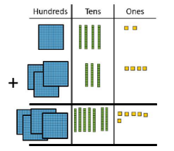  No re-grouping:  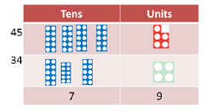  - Model using dienes, place value counters or numicon.  - Add together the ones first, then the tens.  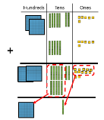  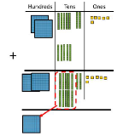  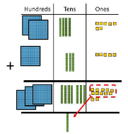  With re-grouping:  (ones to tens) (tens to hundreds) (ones and tens) | Pictorial  No re-grouping:  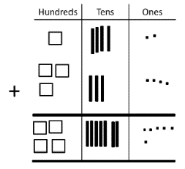  With re-grouping:  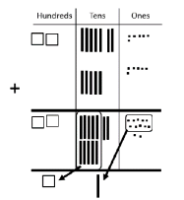  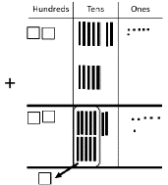  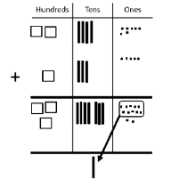  (ones to tens) (tens to hundreds) (ones and tens) |  | Abstract  No re-grouping:  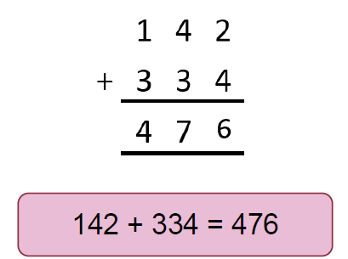  With re-grouping:  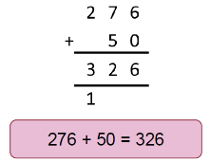  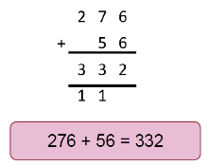  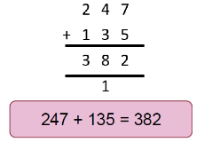  (ones to tens) (tens to hundreds) (ones and tens)
Note: Once pupils have fully understood and rehearsed re-grouping within formal column addition of 3-digit numbers, this learning continues to be rehearsed and applied throughout Years 4, 5 and 6, including to larger numbers, decimals and within the contexts of measures and money.

Year 4
Addition
Mental methods and skills  - Sums of pairs of multiples of 10, 100 or 1000.  - Addition doubles of numbers 1 to 100, e.g. 38 + 38.  - What must be added to any three-digit number to make the next multiple of 100, e.g. 521 + = 600.  - Pairs of fractions that total 1.  - Count on in hundreds, tens and ones.  - Add a near multiple of 10 e.g. 56 + 29  - Add near doubles of two-digit numbers e.g. 38 + 37.  - Add two-digit, three-digit and four digit multiples of 10, e.g. 140 + 150.  - Partition: add a multiple of 10 and adjust e.g. 56 + 29 = 56 + 30 – 1  - Use knowledge of place value and related calculations e.g. work out 140 + 150 = 290 using 14 + 15 = 29  - Partition: count on in minutes and hours, bridging through 60 (analogue and digital times). |  |  | Vocabulary  As previous years plus:  Tenths  Hundredths  Decimal place  Negative integers  Count through 0  Inverse
Written Methods and Skills
In Year 4, pupils will revisit the formal written method first encountered in Year 2, extending to 4 digit numbers and decimals.
Objectives and Strategy:  Formal written method, re-grouping ones to tens, tens to hundreds and hundreds to thousands.  Later the focus switches to adding decimals to 2 d.p.  Pupils at all stages should be encouraged to estimate first and check their answer using a mental method. | Concrete  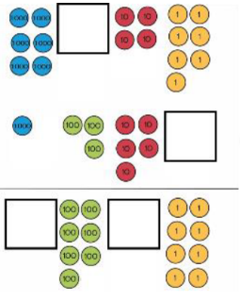  - Children continue to use dienes or place value counters to add  - Including missing number problems  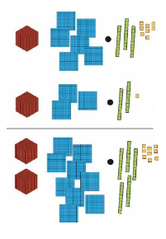  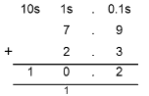  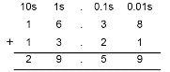  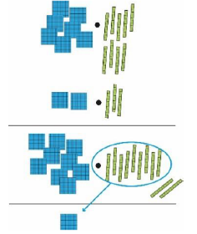  (no re-grouping) (re-grouping) | Pictorial  As for Y3, plus:  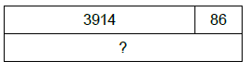  - Children use bar models to support their understanding of problem solving and missing number calculations. |  | Abstract  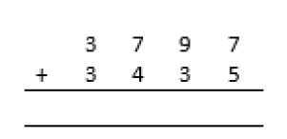  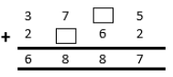  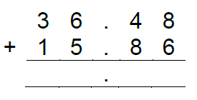
Note: Once pupils have fully understood and rehearsed re-grouping within formal column addition of 4-digit numbers, this learning continues to be rehearsed and applied throughout Years 5 and 6, including to larger numbers and within the contexts of measures and money.
Year 5/6
Addition
Mental methods and skills (Year 5)  - Doubles of decimals, e.g. double 3.4  - What must be added to any four-digit number to make the next multiple of 1000, e.g. 4087 + = 5000.  - What must be added to a decimal with ones and tenths to make the next whole number, e.g. 7.2 + = 8.  - Add a pair of two digit numbers or three digit multiples of 10 e.g. 38 - 86, 350 + 360.  - Add a near multiple of 10 or 100 to any two digit or three digit number, e.g. 235 + 198 (and adjust)  - Add any pairs of decimal fractions each with ones and tenths e.g. 5.7 + 2.5  - Count on in hundreds, tens, ones and tenths from any number  - Partition: add hundreds, tens or ones separately, then recombine.  - Add a multiple of 10 or 100 and adjust.  - Use knowledge of place value and related calculations, e.g. 6.3 + 4.8 using 63 + 48.  - Partition: count on in minutes and hours, bridging through 60 (analogue and digital times).  - Add fractions with same denominator |  |  | Mental methods and skills (Year 6)  - Addition facts for multiples of 10 to 1000 and decimal numbers with one decimal place, e.g. 1.4 + = 2.5  - What must be added to a decimal with ones, tenths and hundredths to make the next whole number e.g. 7.26 + = 8.  - Add pairs of decimals with ones, tenths or hundredths e.g. 0.7 + 3.38.  - Find doubles of decimals each with ones and tenths e.g. 1.6 + 1.6.  - Add near doubles of decimals e.g. 2.5 + 2.6  - Add a decimal with ones and tenths that is nearly a whole number e.g. 4.3 + 2.9.  - Count on in hundreds, tens, ones, tenths and hundredths.  - Use knowledge of place value and related calculations e.g. 680 + 430, 6.8 + 4.3, 0.68 + 0.43 can all be worked out using the related calculation 68 + 43.  - Partition: add a whole number and adjust e.g. 4.3 + 2.9 = 4.3 + 3 – 0.1  Partition: count on in minutes and hours, bridging through 60 (analogue and digital times, 12 hour and 24 hour clock) using number line |  | Vocabulary  As previous years plus:  Year 5  Efficient written method  Year 6  Order of Operations  Numbers to ten million  Thousandths
Written Methods and Skills
In Years 5 and 6, pupils will revisit the formal written method first encountered in Year 2, extending to 5 or more digit numbers and decimals.
Objectives and Strategy:  Formal written method, re-grouping ones to tens, tens to hundreds , hundreds to thousands and thousands to ten thousands.  Add decimals with 2 decimal places, including money.  Pupils at all stages should be encouraged to estimate first and check their answer using a mental method. | Concrete | Pictorial  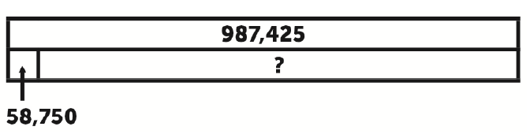  - Children use bar models to support their understanding of problem solving and missing number calculations.  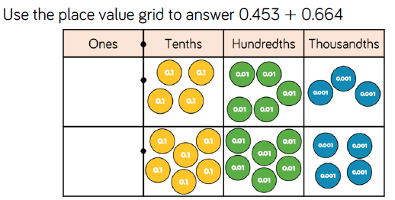 |  | Abstract  56233  12879+  69112  ¹¹¹  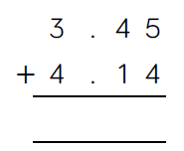  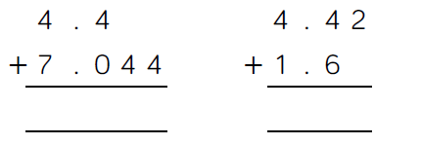
Note: Once pupils have fully understood and rehearsed re-grouping within formal column addition of 5-digit numbers, this learning continues to be rehearsed and applied throughout 6, including adding several numbers of increasing complexity.

Foundation Stage
Subtraction
Key Skills for Subtraction  - Select the correct numeral to represent 1 to 5, then 1 to 10 objects.  - Count an irregular arrangement of up to ten objects.  - Estimate how many objects they can see and check by counting them.  - Use the language of ‘more’ and ‘fewer’ to compare two sets of objects.  - Say the number that is one less than a given number.  - Find one less from a group of up to five objects, then ten objects.  - In practical activities and discussion, begin to use the vocabulary involved in subtraction  - Record, using marks that they can interpret and explain.  - Begin to identify own mathematical problems based on own interests and fascinations | Vocabulary  Take ten less  Take away how many are left/left over?  Leave how many have gone?  Subtract how many fewer is…than…?  Minus smaller  Equals before  Number sentence backwards  Count back  One less  Two less
Written Methods and Skills
- Have an understanding of what “less” means and be able to say what is one less than a given number.  - Children begin to use objects, pictures and concrete apparatus to relate subtraction to taking away and counting how many objects are left.  - Solve simple problems using fingers and introduce Numicon where appropriate.  - Children make a record in pictures, words, Numicon shapes or symbols of subtraction activities already carried out.  - Children are encouraged to read number sentences aloud in different ways e.g. “Five subtract one leaves four” “Six take away 3 equals 3”  - Construct number sentences verbally or using cards to go with practical activities.  - Number lines can be used alongside practical apparatus to solve subtraction calculations and word problems “jump” back to “count down“ the number line. |  | 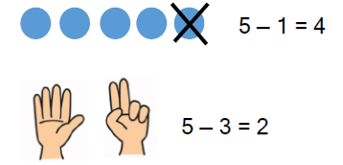  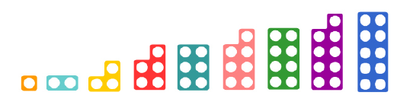  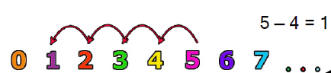

Year 1
Subtraction
Mental methods and skills  - Subtract a pair of single-digit numbers e.g. 8 – 3  - Subtract a single-digit number from a teens numbers e.g. 17 – 3  - Subtract a single-digit from 10 or 20  - Count back in ones, two or tens  - Partition small numbers e.g. 8 – 3 = 8 – 2 – 1  - Know one less  - Know largest and smallest number  - Count back from any number to 50  - Practical strategies to see ‘difference’ to see how many more are needed to make a bigger number  - Know by heart subtraction facts to 10 and 20 |  |  | Vocabulary  Less How many left  Before Fewer  Lowest How many more  Highest Partition  Number sentence Digit  Difference Teens number  Less than Subtraction  Subtract Equals  Take away minus
Written Methods and Skills
Objective and Strategy  Taking one away | Concrete  Use physical objects, counters, cubes etc to show how objects can be taken away  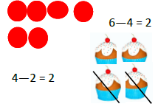 | Pictorial  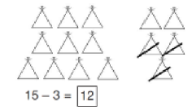  Cross out drawn objects to show what has been taken away. |  | Abstract  7-4=3  16-9=7
Counting back |   Move objects away from the group, counting backwards  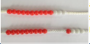  Move the beads along the bead string as you count backwards. | 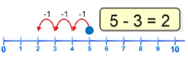  Count back in ones using a number line. |  | Put 13 in your head, count back 4. What number are you at?
Find the difference | Compare objects and amounts  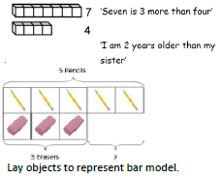 | Count on using a number line to find the difference  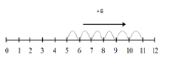 |  | Hannah has 12 sweets and her sister has 5 sweets. How many more does Hannah have than her sister?
Represent and use number bonds and related subtraction facts within 20  Part whole model | Link to addition. Use whole part model to model the inverse.  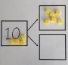  If 10 is the whole and 6 is one of the parts, what’s the other part?  10-6=4 | 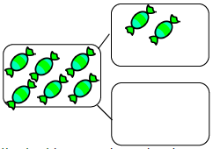  Use pictorial representations to show the part. |  | Move to using numbers within the part whole model.  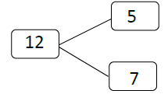  B-S=S
Make 10 | 14 – 9 =  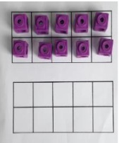  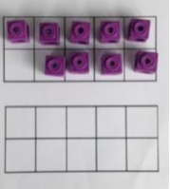  Make 14 on the ten frame. Take away the four first to make 10 and then takeaway one more so you have taken away 5. You are left with the answer of 9. | 13-7  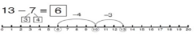  Jump back 3 first, then another 4. Use ten as a stopping point. |  | How many do we take off first to get to 10? How many left to take off?  16-8
Bar Model | 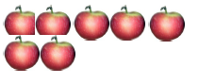  5-2=3 | 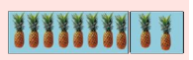 |  | 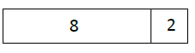  10=8+2  10=2+8  10-2=8  10-8=2
Year 2
Subtraction
Mental methods and skills  - Subtraction facts for all numbers up to at least 20 e.g. 8 – 5  - What must be subtracted from any two-digit number to make the next multiple of 10 e.g. 52 - = 50  - Know largest number comes first when subtracting  - Partition: bridge through 10 and multiples of 10 when subtracting  - Partition: count on or back in tens and ones to find the difference  - Know halves of numbers to 20  - Subtract a single-digit number from a two-digit number, including crossing the tens boundary e.g. 57 – 3, 52 – 7, 37 – 12 = 37 – 10 – 2  - Subtract a multiple of 10 from any two-digit number e.g. 72 – 50  - Subtract 9, 19, 29 ..... or 11, 21, 31 ... by subtracting a multiple of 10 and adjusting  - Subtract any single-digit number from a multiple of 10 e.g. 80 – 7  - Subtract a pair of single-digit numbers, including crossing 10 e.g. 12 – 7  - Subtract a 2 digit number from a 2 digit number |  |  | Vocabulary  Less How many left Difference  Before Fewer Minus  Lowest How many more  Highest Partition  Number sentence Digit  Difference Teens number  Less than Subtraction  Subtract Equals  Take away Difference between
Written Methods and Skills
Objective and Strategy  Regroup a ten into tens and ones | Concrete  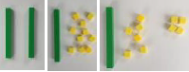 | Pictorial  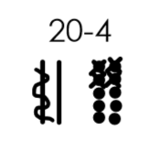 |  | Abstract  20-4=16  B-S=S
Partitioning to subtract without regrouping. | 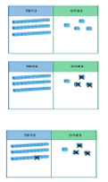  34-13=21  Use Dienes to show  how to partition the  number when subtracting  Without regrouping. | Children draw representations of Dienes and cross off.  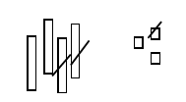  43-21= |  | 43-21=22
Make ten strategy  Progression should be crossing one ten, crossing more than one ten, crossing the hundreds. | 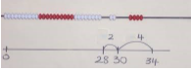  Use a bead bar or bead strings to model counting to next ten and the rest. | 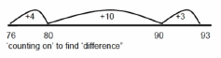  Use a number line to count on to next ten and then the rest. |  | 53-18=  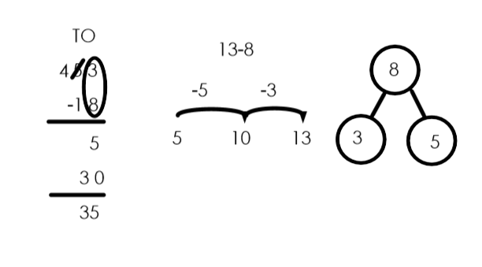

Year 3
Subtraction
Mental methods and skills  - Subtract groups of small numbers e.g. 15 – 3 - 8  - Subtract a two-digit number from a multiple of 10 e.g., 90 – 27.  - Subtract three-digit numbers e.g. 268 – 135.  - Subtraction facts for all numbers to 20 e.g. 17 – 9, drawing on knowledge of inverse operations.  - Differences of multiples of 10, e.g. 120 – 90  - Subtract by counting up from the smallest number to the largest number.  - Partition: count back in tens and ones to find the difference.  - Partition: subtract 10 or 20 and adjust.  - Partition: count back in minutes and hours, bridging through 60 (analogue times).  - Make decisions about whether to count on or back to subtract.  - Differences of pairs of multiples of 10,100 or 1000 |  |  | Vocabulary  As previous years plus:  Column subtraction
Written Methods and Skills
In Year 3, pupils will revisit the formal written method first encountered in Year 2, extending to 3 digit numbers and introducing re-grouping.
Objectives and Strategy:  Formal written method, initially with no re-grouping but introducing hundreds.  Later, the focus switches to re-grouping  Pupils at all stages should be encouraged to estimate first and check their answer using a mental method. | Concrete  No re-grouping:  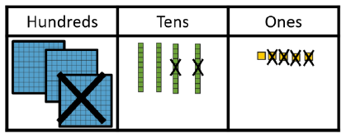  - Model using dienes, place value counters or numicon.  - Subtract the ones first, then the tens.  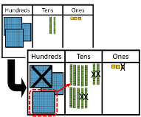  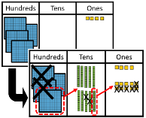  With re-grouping:  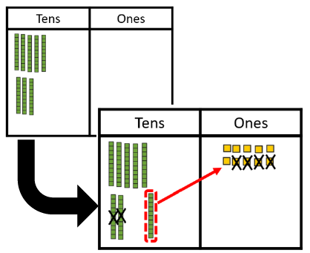  (tens to ones) (hundreds to tens) (tens and hundreds) | Pictorial  No re-grouping:  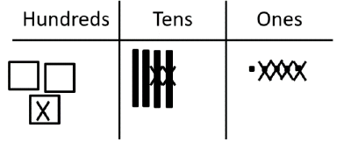  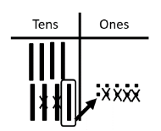  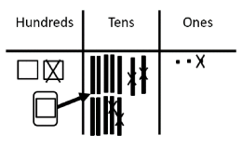  With re-grouping:  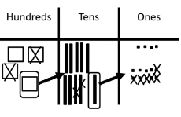  (tens to ones) (hundreds to tens) (ones and tens) |  | Abstract  No re-grouping:  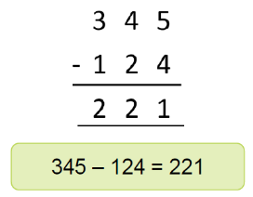  With re-grouping:  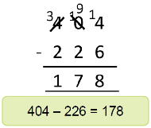  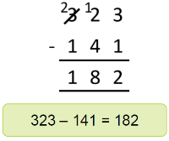  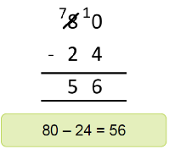  (tens to ones) (hundreds to tens) (tens and hundreds)
 | It is important that pupils start to identify where regrouping is necessary. Ensure that pupils are confident that the minuend may have been regrouped but it is still of equal value prior to subtraction.
Note: Once pupils have fully understood and rehearsed regrouping within formal subtraction, this learning continues to be rehearsed and applied throughout Years 4, 5 and 6, including to multi-digit, decimal numbers, money and measures.
Year 4
Subtraction
Mental methods and skills  - Count back in hundreds, tens and ones  - Partition: subtract tens and then ones e.g. subtracting 27 by subtracting 20 then 7.  - Subtract by counting up from the smaller to the larger number.  - Partition: subtract a multiple of 10 and adjust e.g. 86 – 38 = 86 – 40 +2.  - Use knowledge of place value and related calculations e.g. work out  290 – 150 = 140 because 29-15=14  - Partition: count back in minutes and hours, bridging through 60 (analogue and digital times).  - Subtract any pair of two-digit numbers, including crossing the tens and 100 boundary e.g. 91 – 35  - Subtract two-digit or three-digit multiples of 10 e.g. 120 – 40, 370 – 180 |  |  | Vocabulary  As previous years plus:  Tenths  Hundredths  Decimal place  Negative integers  Count through 0
Written Methods and Skills
In Year 4, pupils will revisit the formal written method first encountered in Year 2, extending to 4 digit numbers and decimals in the context of money.
Objectives and Strategy:  Formal written method, re-grouping ones to tens, tens to hundreds and hundreds to thousands.  Later the focus switches to adding decimals to 2 d.p.  Pupils at all stages should be encouraged to estimate first and check their answer using a mental method. | Concrete  - Children continue to use dienes or place value counters to subtract  - Including missing number problems  3.45 – 1.24 3.44 – 1.25  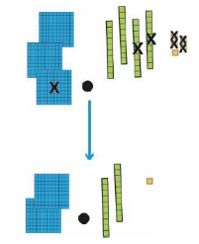  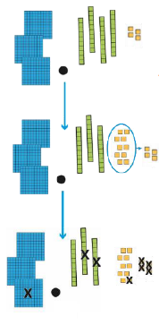  (no re-grouping) (re-grouping) | Pictorial  As for Y3    - Children use bar models to support their understanding of problem solving and missing number calculations. |  | Abstract  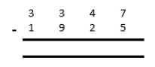  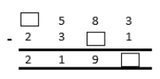  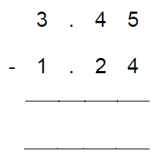
Note: Once pupils have fully understood and rehearsed re-grouping within formal column addition of 4-digit numbers, this learning continues to be rehearsed and applied throughout Years 5 and 6, including to larger numbers and within the contexts of measures and money.

Year 5/6
Subtraction
Mental methods and skills (Year 5)  - Count back in hundreds, tens, ones and tenths.  - Subtract by counting up from the smaller to the larger number.  - Subtract a multiple of 10 or 100 and adjust.  - Use knowledge of place value and related calculations e.g. 6.3 – 4.8 using 63 – 48  - Partition: count back in minutes and hours, bridging through 60 (analogue and digital times).  - Subtract a pair of two-digit numbers or three-digit multiples of 10 e.g. 620 – 380  - Subtract a near multiple of 10 or 100 to any two-digit or three-digit number e.g. 235 – 198  - Find the difference between near multiples of 100 e.g. 607 – 588 or of 1000 e.g. 6070 – 4087  - Subtract any pairs of decimal fractions each with ones and tenths e.g. 6.3 – 4.8  - Differences of decimals e.g. 7.8 – 1.3  - Doubles and halves of decimals e.g. half of 5.6, double 3.4  - Subtract fraction with same denominator |  |  | Mental methods and skills (Year 6)  - Count back in hundreds, tens, ones, tenths and hundredths  - Use knowledge of place value and related calculations e.g. 111 – 68 = 43 can be worked out using the related calculation 1.11 – 0.68 = 0.43  - Partition: subtract a whole number and adjust e.g. 6.5 – 3.8 = 6.5 – 4 + 0.2  - Partition: count back in minutes and hours, bridging through 60 (analogue and digital times, 12 hour and 24 hour clock).  - Subtraction facts for multiples of 10 to 1000 and decimal numbers with one decimal place e.g. – 1.4 = 2.5  - What must be added to a decimal with ones, tenths and hundredths to make the next whole number e.g. 7.26 + = 8 TO SOLVE 8 – 7.26  - Subtract a decimal with ones and tenths, that is nearly a whole number e.g. 6.5 – 3.8  - Subtract pairs of decimals with ones, tenths or hundredths e.g. 3.38 – 0.7 |  | Vocabulary  As previous years plus:  Year 5  Efficient written method  Year 6  Order of Operations  Numbers to ten million  Thousandths
Written Methods and Skills
In Years 5 and 6, pupils will revisit the formal written method first encountered in Year 2, extending to 5 or more digit numbers and decimals.
Objectives and Strategy:  Formal written method, re-grouping ones to tens, tens to hundreds , hundreds to thousands and thousands to ten thousands.  Subtract decimals with 2 decimal places, including money, using 0 as a place holder.  Pupils at all stages should be encouraged to estimate first and check their answer using a mental method. | Concrete  As for years 3 and 4 | Pictorial  As for years 3 and 4, plus:  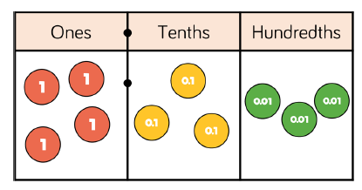  4.33 – 2.14  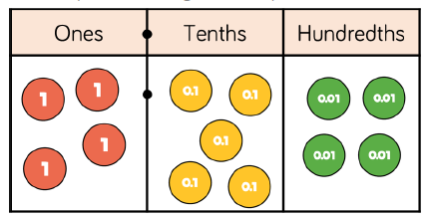  4.54 – 1.4 |  | Abstract  As for years 3 and 4, plus:  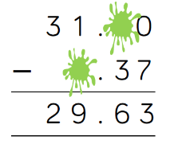  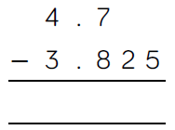  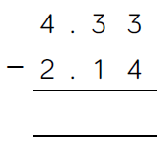
Note: Once pupils have fully understood and rehearsed re-grouping within formal column addition of 5-digit numbers, this learning continues to be rehearsed and applied throughout 6, including adding several numbers of increasing complexity.

Foundation Stage
Multiplication
Key Skills for multiplication  - Select the correct numeral to represent 1 to 5, then 1 to 10 objects.  - Count an irregular arrangement of up to ten objects.  - Estimate how many objects they can see and check by counting them.  - Find the total number of items in two groups by counting all of them.  - Record, using marks that they can interpret and explain.  - Begin to identify own mathematical problems based on own interests and fascinations. | Vocabulary  Lots of tens  Groups of odds  Times evens  Repeated addition  Double  Combine  Twos  Fives
Written Methods and Skills
- Multiplication can be introduced through doubling of a number. Children show they have 2 lots of the same number.  - Children begin with mostly pictorial representations.  - Real life contexts and use of practical equipment to count in repeated groups of the same size.  - Count in twos, fives and tens, both aloud and with objects, such as Numicon or other concrete apparatus.  - Children are encouraged to read number sentences aloud in different ways e.g. “Five groups of two makes ten” “Three lots of two makes six”  - Children are given multiplication problems set in a real life context and are encouraged to visualise the problem. e.g.  “How many fingers on two hands?” “How many sides on three triangles?”  How many legs on four ducks?” |  | 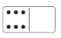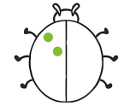    How many groups of 2 are there? 3 groups of 2 = 6  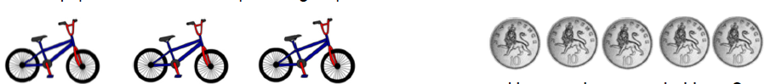  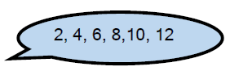  How many wheels altogether? How much money do I have?    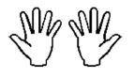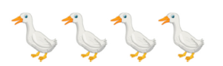

Year 1
Multiplication
Mental methods and skills  - Count on from and back to zero in ones, twos, fives or tens  - Doubles of all numbers to 10, e.g. double 6  - Odd and even numbers to 20  - Use patterns of last digits e.g. 0 and 5 when counting in fives.  - Think of multiplication as repeated addition e.g. 2+2+2+2 or 5+5+5 or 10p + 10p + 10p +10p |  |  | Vocabulary  Odd Fives  Even Tens  Twos Lots of  Double Groups of  Once Twice  Digit multiply  Repeated addition
Written Methods and Skills
Objective and Strategy  Doubling | Concrete  Use practical activities using manipulatives to demonstrate doubling  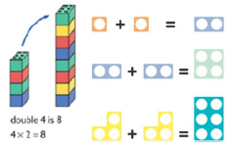 | Pictorial  Draw pictures to show how to double numbers.  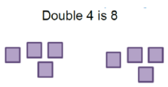 |  | Abstract  Partition a number and then double each part before recombining it back together.  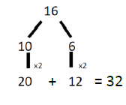
Counting in multiples | Count the groups as children are counting, children may use their fingers as they are counting.  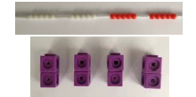 | 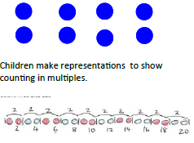 |  | Count in multiples of a number aloud.  Write sequences with multiples of numbers.  2, 4, 6, 8, 10  5, 10, 15, 20, 25 , 30
Making equal groups and counting the total | 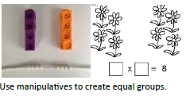 | 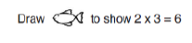  Draw and make representations. |  | 2x4=8
Repeated addition | 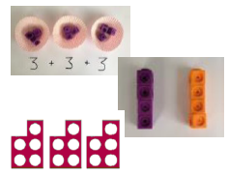  Use different objects to add equal groups | Use pictorial including number lines to solve problems.  There are 3 sweets in one bag. How many sweets are in 5 bags altogether?  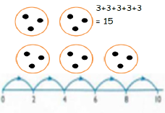 |  | Write addition sentences to describe objects and pictures.  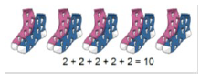
Understanding arrays | Use objects laid out in arrays to find the answer to 2 lots of 5, 3 lots of 2 etc   | Draw representations of arrays to show understanding.  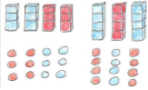 |  | 3x2=6  2x5=10

Year 2
Multiplication
Mental methods and skills  - Doubles of all numbers to 20 e.g. double 13, and corresponding halves.  - Doubles of multiples of 10 to 50 e.g. double 40 and corresponding halves.  - Multiplication facts for the 2, 5 and 10 times-tables, and corresponding division facts  - Odd and even numbers to 100  - Double any multiple of 5 up to 50 e.g. double 35  - Find the total number of objects when they are organised into groups of 2, 5 or 10.  - Understand multiplication as a) repeated addition  b) arrays  - Partition: double the tens and ones separately, then recombine  - Use knowledge that doubling is equivalent to multiplying by two.  - Use knowledge of multiplication facts from the 2, 5 and 10 times tables e.g. recognise that there are 15 objects altogether because there are three groups of five.  - Know multiplication can be done in any order (Commutative law)  - Know how to represent arrays on a number line. |  |  | Vocabulary  Odd Multiply row Fives  Even Multiple(s) recombine Tens  Twos Times inverse Lots of  Double Arrays altogether three  Once Column order  Twice Partition pairs  Digit x symbol groups of  Repeated addition
Written Methods and Skills
Objective and Strategy  Doubling | Concrete  Model doubling using Dienes and counters.  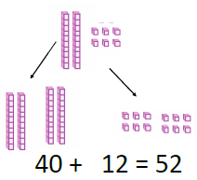 | Pictorial  Draw pictures and representations to show how to double numbers. |  | Abstract  Partition a number and then double each part before recombining it back together.  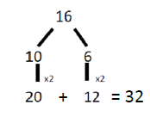
Counting in multiples of 2,3, 4, 5, 10 from 0  (Repeated addition) | Count the groups as children are counting, children may use their fingers as they are skip counting. Use bar models.  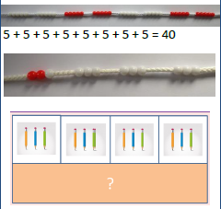 | Number lines, counting sticks and bar models should be used to show representation of counting in multiples.  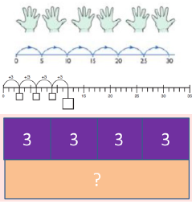 |  | Count in multiples of a number aloud.  Write sequences with multiplies of number.  0, 2, 4, 6, 8, 10  0, 3, 6, 9, 12, 15  0, 5, 10, 15, 20, 25, 30  4x3=
Multiplication is commutative | Create arrays using counters, cubes and numicon.  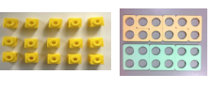  Pupils should understand that an array can represent different equations and that, as multiplication is commutative, the order of multiplication does not affect the answer.  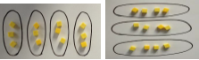 | Use representations of arrays to show different calculations and explore commutativity.  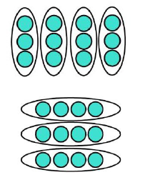 |  | 12 = 3x4  12=4x3  Use arrays to write multiplication sentences and reinforce repeated addition.  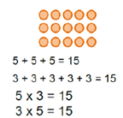
Using the inverse  This should be taught alongside division, so pupils learn how they work alongside each other. | 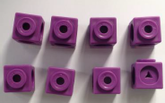 | 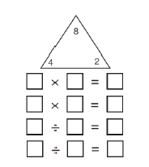 |  | 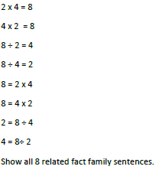

Year 3
Multiplication
Mental methods and skills  - Multiplication facts for the 2,3,4,5,6,8 and 10 times tables and corresponding division facts.  - Doubles of multiples of 10 to 100 e.g. double 90 and corresponding halves.  - Double any multiple of 5 up to 100 e.g. double 35.  - Partition: when doubling, double the tens and ones separately then recombine.  - Use knowledge that halving and doubling are inverse operations.  - Know associative law i.e. 6 x 4 = 6 x (2x2)  - Know distributive law i.e. 5 x 6 = (5x2) + (5x4)  - Multiply one digit or two-digit numbers by 10 or 100 e.g. 7 x 100, 46 x 10, 54 x 100  - Recognise that when multiplying by 10 or 100 the digits move one or two places to the left and zero is used as a place holder.  - Find one fractions and simple non-one fractions of numbers and quantities e.g 3/8 of 24 by dividing 8x3 |  |  | Vocabulary  As previous years plus:  Product  Multiples of four, eight, fifty and one hundred  Scale up
Written Methods and Skills
Pupils have already met the distributive law and rehearsed multiplying by ten. The focus of this year is to support pupils in making the connection between the informal distributive approach and a formal layout.
Objectives and Strategy:  Introducing short multiplication with no re-grouping  Later, the focus switches to re-grouping and  may include 3-digit numbers  Pupils at all stages should be encouraged to estimate first and check their answer using a mental method. | Concrete  No re-grouping:  e.g. 12 x 3  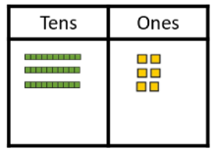  - Model using dienes, place value counters or numicon.  With re-grouping:  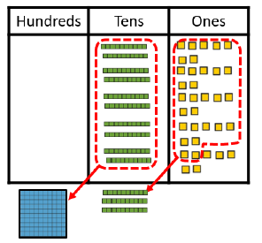  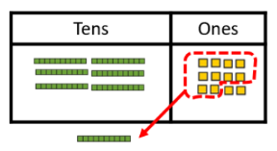  e.g. 24 x 3 27 x 5  (ones to tens) (ones and tens) | Pictorial  No re-grouping:  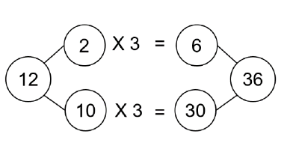  With re-grouping:  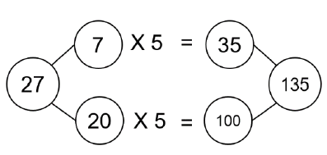  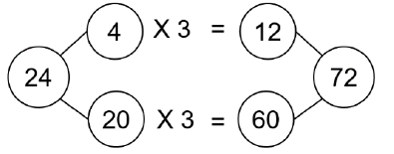  (ones to tens) (ones and tens) |  | Abstract  No re-grouping:  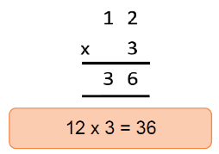  With re-grouping:  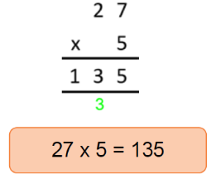  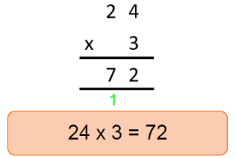  (ones to tens) (ones and tens)
Note: At this stage, the pictorial representation is being used as a checking point to ensure pupils answer accurately. This allows focused attention on understanding the abstract recording.

Year 4
Multiplication
Mental methods and skills  - Multiplication facts to 12 x 12 and the corresponding division facts.  - Doubles of numbers 1 to 100 e.g. double 58 and corresponding halves.  - Doubles of multiples of 10 and 100 and corresponding halves  - Factor pairs for known multiplication facts.  - Double any two-digit number e.g. double 39.  - Double any multiple of 10 or 100 e.g. double 340, double 800 and halve the corresponding multiples of 10 and 100.  - Multiply a multiple of 10 to 100 by a single-digit number e.g. 40 x 3.  - Multiply numbers to 20 by a single-digit e.g. 17 x 3 using partitioning.  - Multiply numbers to 1000 by 10 and then 100 (whole-number answers) e.g. 325 x 10, 42 x 100  - Partition: double the tens and ones separately, then recombine.  - Use understanding that when a number is multiplied or divided by 10 or 100 its digits move one or two places to the left or the right and zero is used as a place holder.  - Use knowledge of multiplication facts and place value e.g. 7 x 8 = 56 to find 70 x 8, 7 x 80.  - Use partitioning and the distributive law to multiply e.g. 13 x 4 = (10 + 3) x 4  = (10 x 4) + (3 x 4)  = 40 + 12 = 52  - Multiply by 0 and 1  - Multiply 3 numbers |  |  | Vocabulary  As previous years plus:  Multiplication facts up to (12x12)  Inverse  Derive
Written Methods and Skills
Pupils continue to develop their understanding of formal written multiplication to include 3 and 4-digit numbers with re-grouping which generates a new column.
Objectives and Strategy:  Formal written multiplication with regrouping which generates a new column  Pupils at all stages should be encouraged to estimate first and check their answer using a mental method. | Concrete  e.g. 421 x 3  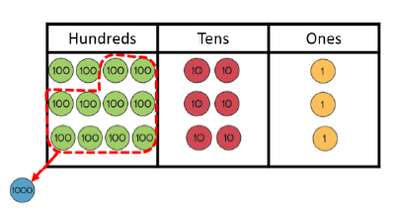  - Model using dienes or place value counters | Pictorial  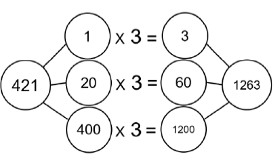 |  | Abstract  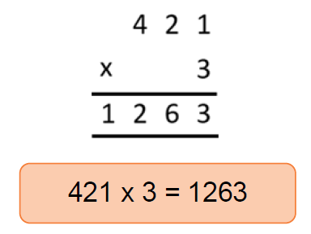
Note: At this stage, the pictorial representation is being used as a checking point to ensure pupils answer accurately. This allows focused attention on understanding the abstract recording.

Year 5
Multiplication
Mental methods and skills  - Squares to 10 x 10  - Multiply whole numbers and decimals by 10, 100 or 1000 e.g. 4.3 x 10, 0.75 x 100.  - Multiply pairs of multiples of 10 e.g. 60 x 30 and a multiple of 100 by a single digit number e.g. 900 x 8.  - Find fractions of whole numbers or quantities e.g. 2/3 of 27, 4/5 of 70 kg using ÷ and x.  - Find factor pairs for numbers to 100, e.g. 30, 2 x 15, 3 x 10 and 5 x 6.  - Be able to choose an efficient method  - Multiply two-digit numbers by 4 or 8 e.g. 26 x 4 by repeated doubling.  - Multiply two-digit numbers by 5 or 20 e.g. 320 x 5, 14 x 20 i.e. to x by 5, x by 10 and half or x 20 is x 10 and double.  - Multiply by 25 and 50 e.g. 48 x 25, 32 x 50.  - Double three-digit multiples of 10 to 500 e.g. 380 x 2.  - Use knowledge of doubles and understanding of place value e.g. when multiplying by 50 multiply by 100 and divide by 2.  - Use understanding that when a number is multiplied or divided by 10 or 100, its digits move one or two places to the left relative to the decimal point and zero is used as a place holder.  - Up to 4 digit numbers  - Understand square and cubed numbers  - X proper fractions and mixed numbers by whole numbers |  |  | Vocabulary  As previous years plus:  Factor pairs  Composite numbers  Prime number,  Prime factor  Square number  Cubed number  Formal written method
Written Methods and Skills
Expanded vertical multiplication progressing to long multiplication of 2-digit by 2-digit numbers with simple regrouping. Pupils also continue to develop their use of short multiplication to include larger numbers.
Objectives and Strategy:  Expanded vertical multiplication:  2-digit by 2-digit, introducing long multiplication when ready.  Long multiplication: 2-digit by 2-digit, focusing on regroup in first partial product  Pupils at all stages should be encouraged to estimate first and check their answer using a mental method. | Concrete  e.g. 32 x 14  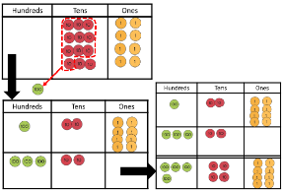  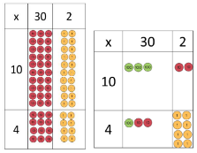  e.g. 32 x 16  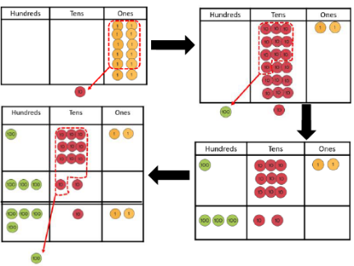  - Model using dienes or place value counters | Pictorial  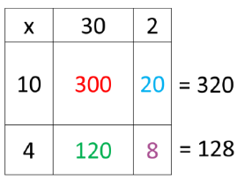  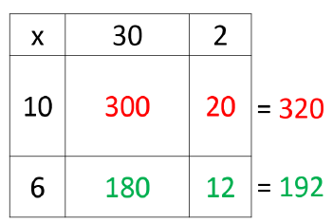 |  | Abstract  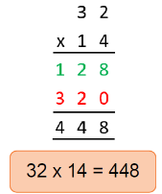  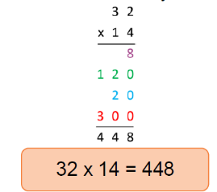  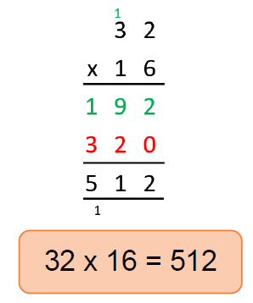

Long multiplication: regrouping in first and second stage.  Pupils at all stages should be encouraged to estimate first and check their answer using a mental method. | e.g. 132 x 46  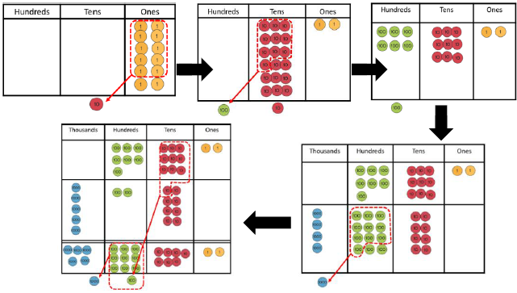  - Model using dienes or place value counters | 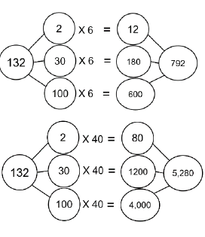  = 6,072 | 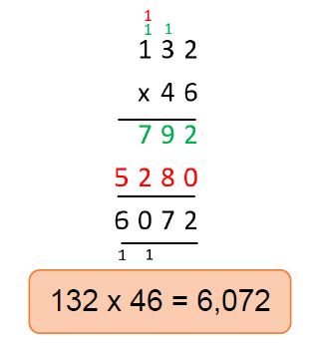
  x | 100 | 30 | 2
  40 | 4000 | 1200 | 80 | = 5280
  6 | 600 | 180 | 12 | = 792
Note: This is a transitional method towards long multiplication. Using the grid supports pupils in their thinking about multiplying by powers of ten and place value. Secure understanding of both of these concepts allows pupils to move to long multiplication more successfully.

Year 6
Multiplication
Mental methods and skills  - Square numbers to 12 x 12  - Squares of the corresponding multiples of 10  - Prime numbers less than 100  - Identify numbers with odd and even numbers of factors and no factor pairs other than 1 and themselves.  - Use knowledge of multiplication and division facts to identify factor pairs and numbers with only two factors.  - Multiply pairs of two-digit and single-digit numbers e.g. 28 x 3  - Double decimals with ones and tenths e.g. double 7.6  - Multiply decimals by 10 or 100 and understand its digits move one or two places to the left relative to the decimal point and that zero is one place holder i.e. 0.078 x 100 = 7.8  - Multiply pairs of multiples of 10 and 100 e.g. 50 x 30, 600 x 20  - Multiply two-digit decimals such as 0.8 x 7  - Recognise how to scale up or down using multiplication and division e.g. if three oranges cost 24p, One orange costs 24 ÷ 3 = 8p, Four oranges cost 8 x 4 = 32p  - Find 10% or multiples of 10% of numbers and quantities i.e. 70% of 200 g  - Understand ‘powers’  - Be able to choose an efficient method.  - Multiply integers by fractions  - Solve multiplications with brackets  - Multiply negative numbers |  |  | Vocabulary  As previous years plus:  Common factors  Common multiples
Written Methods and Skills
In Year 6, pupils will revisit formal long multiplication, extending to larger numbers and decimals.
Objectives and Strategy:  Formal written multiplication involving numbers with up to 2 decimal places multiplied by a 1-digit number. | Concrete  e.g. 34.2 x 6  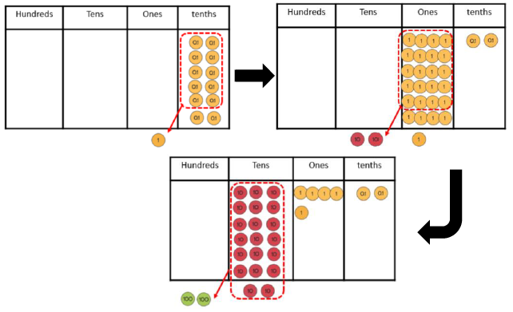  - Model using dienes or place value counters | Pictorial  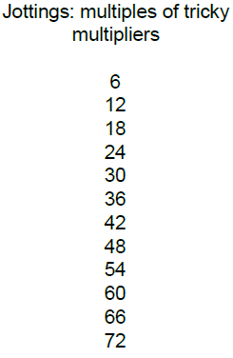 |  |  | Abstract  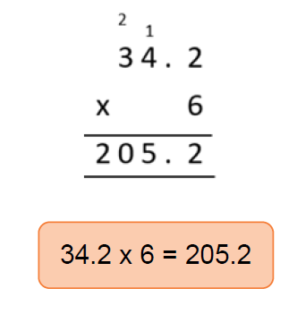
Additional Year 6 Examples:  Long multiplication; up to 4-digit by 2-digit.  Pupils at all stages should be encouraged to estimate first and check their answer using a mental method. | Pictorial  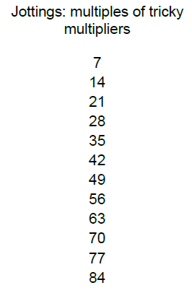 |  |  | Abstract  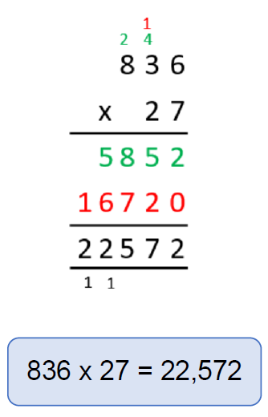
NOTE: These additional examples show only jottings and abstract recording. This complexity of calculation should only be introduced to pupils when they are confident in the conceptual pathway and can explain the abstract recording with reference to the concrete and pictorial models.

Foundation Stage
Division
Key Skills for Division  - Share toys/counting equipment between 2 or 3  - Count to check each group has the same  - Put apparatus into groups of two, three, four or five  - Notice when groups of objects are ‘the same’  - Share objects using ‘1 for you’ ‘1 for you’ between bags, plates, bowls, hoops etc.  - Cut objects and shapes in half with knives and scissors. | Vocabulary  Share Groups Fours Half  Equal Ones Fives Threes  Fair Twos Same Halves
Written Methods and Skills
- Division can be introduced through halving or sharing an equal amounts into 2 groups.  - Children begin with mostly pictorial representations linked to real life context.  - Children need to see and hear representations of division as both grouping and sharing.  Grouping model  Mum has 6 socks. She grouped them into pairs. How many pairs did she make?  Sharing model  I have 10 sweets. I want to share them with my friend. How many will we have each?  - Children make a record in pictures, words or symbols of division activities.  - Children are encouraged to have a go at recording the calculation that has been carried out e.g. by arranging concrete objects into groups. |  | 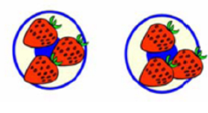    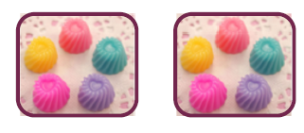  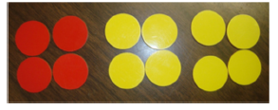

Year 1
Division
Mental methods and skills  - Share toys/counting equipment between 2 or 3  - Count to check each group has the same  - Put apparatus into groups of two, three, four or five  - Notice when groups of objects are ‘the same’  - Share objects using ‘1 for you’ ‘1 for you’ between bags, plates, bowls, hoops etc.  - Cut objects and shapes in half with knives and scissors.  - Count back in ones, twos, fives and tens.  - Halves of all numbers to 10  - Begin to know halves of numbers to 20  - Know when we share we get ‘less’  - Odd/even numbers  - Understand division as sharing (one for you) and grouping.  - Cut shapes, pieces of string, card in half  - Compare two halves and see that they are exactly the same. |  |  | Vocabulary  Share Groups Fours Half  Equal Ones Fives Threes  Fair Twos Same Halves  Equal Back Backwards Smaller  Less Fewer Exactly
Written Methods and Skills
Objective and Strategy  Division as sharing | Concrete  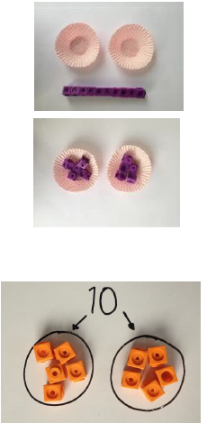I have 10 cubes, can you share them equally in 2 groups? | Pictorial  Children use pictures or shapes to share quantities.  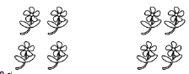  8 shared between 2 is 4  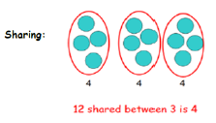 |  | Abstract  12 shared between 3 is 4

Year 2
Division
Mental methods and skills  - Share toys/counting equipment between 2 or 3  - Count to check each group has the same  - Put apparatus into groups of two, three, four or five  - Notice when groups of objects are ‘the same’  - Share objects using ‘1 for you’ ‘1 for you’ between bags, plates, bowls, hoops etc.  - Cut objects and shapes in half with knives and scissors.  - Count back in ones, twos, fives and tens.  - Know halves of numbers to 20  - Know when we share we get ‘less’  - Odd/even numbers  - Understand division as sharing (one for you) and grouping.  - Cut shapes, pieces of string, card in half  - Compare two halves and see that they are exactly the same.  - Halves of multiples of 10 to 100  - Division facts for 2, 5, 10 x tables  - Odd and even numbers to 100  - Find half of even numbers to 40  - Use knowledge that halving is the inverse of doubling  - Put an odd number of objects into groups of 2 and see what’s ‘left over’  - Know/understand division as repeated subtraction  - Understand division as sharing (one for you) and grouping.  - Understand division as grouping through arrays. |  |  | Vocabulary  Share Groups Fours Half  Equal Ones Fives Threes  Fair Twos Same Halves  Equal Back Backwards Smaller  Less Fewer Exactly  Divide Inverse Remainder Left over  Arrays Repeated subtraction
Written Methods and Skills
Objective and Strategy  Division as sharing | Concrete  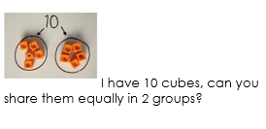 | Pictorial  Children use pictures or shapes to share quantities.  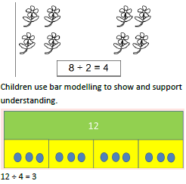 |  | Abstract  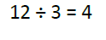
Division as grouping | 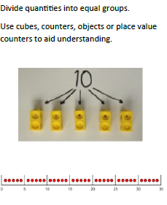 | 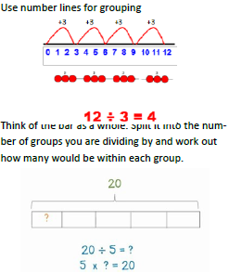 |  | 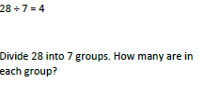

Year 3
Division
Mental methods and skills  - Halve any multiple of 10 up to 200 e.g. halve 170  - Find one fractions of numbers and quantities involving halves, thirds, quarters, fifths and tenths i.e. find 1/5 by dividing by 5  - Multiplication facts for the 2, 3, 4, 5, 6 and 10 times-tables and corresponding division facts.  - Doubles of multiples of 10 to 100 e.g. double 90 and corresponding halves.  - Use knowledge of multiples to find quotients i.e. 15 ÷ 3 = 5 because there are five threes in fifteen.  - Partition: when halving, halve the tens and ones separately, then recombine.  - Use knowledge that halving and doubling are Inverse operations.  - Recognise that finding a one fraction is equivalent to dividing by the denominator and use knowledge of division facts.  - Recognise that when dividing by 10 or 100 the digits move one or two places to the right and zero is used as a place holder.  - Know there will be ‘left overs’ if you have a number that is not a multiple of the divisor. |  |  | Vocabulary  As previous years plus:  Product  Multiples of four, eight, fifty and one hundred  Scale up
Written Methods and Skills
Pupils are introduced to the long division method for the first time in Year 3. Short division will not be introduced until pupils have understood all of the stages in this expanded form.
Objectives and Strategy:  Introducing the long division method (sharing ones)  Long division of tens and ones with no regrouping (sharing structure)  Long division of tens and ones with regrouping (sharing structure)  Pupils at all stages should be encouraged to estimate first and check their answer using a mental method. | Concrete  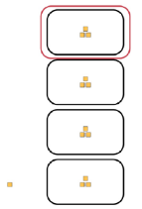  e.g. 13 ÷ 4 = 3^{r}1  e.g. 84 ÷ 2 = 42  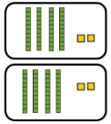  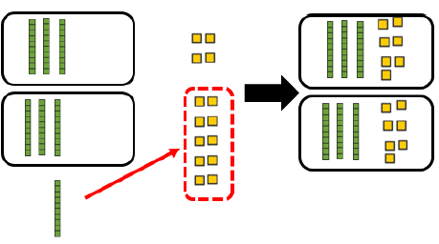  e.g. 74 ÷ 2 = 37 | Pictorial  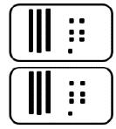  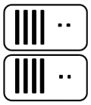  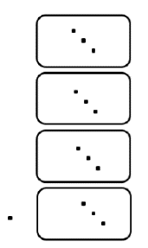 |  | 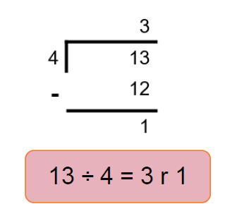  Abstract  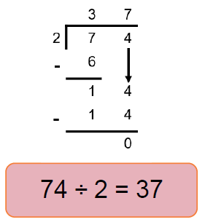  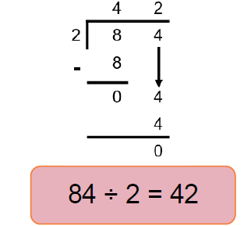
Note: It is important for children to understand the expanded form before using short division because, in the calculation 96 ÷ 4 for example, pupils often struggle to understand that 1 ten will be regrouped after 8 tens have been used in the 4 groups. This is hidden in short division but recorded in long division.

Year 4
Division
Mental methods and skills  - Multiplication facts to 12 x 12 and the corresponding division facts.  - Doubles of numbers 1 to 100 e.g. double 58, and corresponding halves.  - Doubles of multiples of 10 and 100 and corresponding halves.  - Fraction and decimal equivalents of one-half, quarters, tenths and hundredths e.g. 3/10 is 0.3 and 3/100 is 0.03  - Partition: halve the tens and ones separately, then recombine.  - Use understanding that when a number is divided by 10 or 100, its digits move one or two places to the right and zero is used as a place holder.  - Choose an efficient method  - Use knowledge of multiplication facts and place value e.g. 56 ÷ 8 = 7 so  560 ÷8 = 70  - Double any multiple of 10 or 100 e.g. double 340, double 800 and halve the corresponding multiples of 10 and 100.  - Halve any even numbers to 200.  - Divide numbers to 1000 by 10 and then 100 (whole number and decimal answers) e.g. 120 ÷ 10, 600 ÷ 100, 850 ÷ 10  - Identify the remainder when dividing by 2, 5, 10  - Give the factor pair associated with a multiplication fact e.g. identify that if 2 x 3 = 6 then 6 has the factor pair 2 and 3. |  |  | Vocabulary  As previous years plus:  Multiplication facts up to (!2x12),  Inverse  Derive
Written Methods and Skills
Pupils revisit long division with no regrouping and exact answers. This is to ensure that they understand the abstract recording of long division.
Objectives and Strategy:  Long division with regrouping hundreds in to tens (sharing structure)  Introducing formal short division (sharing structure).  Pupils at all stages should be encouraged to estimate first and check their answer using a mental method. | Concrete  e.g. 426 ÷ 3 = 142  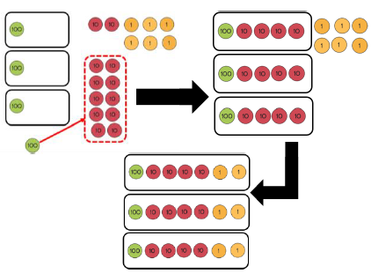 | Pictorial  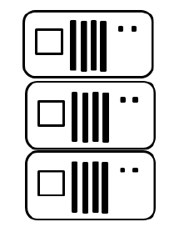 |  | Abstract  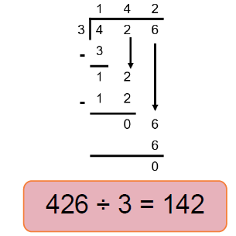  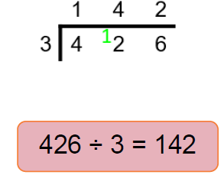
Note: In this stage, pupils learn that the thinking processes for long and short division are the same – it is only the abstract written that is different. It is important that pupils are able to link this to the long division format and can explain the compaction.

Year 5
Division
Mental methods and skills  - Division facts corresponding to tables up to 10 x 10 and the related one fractions e.g. 7 x 9 = 63 so one-ninth of 63 is 7 and one-seventh of 63 is 9.  - Percentage equivalents of one-half, one-quarter, three-quarters, tenths and hundredths.  - Factor pairs to 100  - Divide by 4 or 8 by repeated halving, or 5 &10.  - Form an equivalent calculation e.g. to multiply by 5, multiply by 10 then halve, to multiply by 20, double, then multiply by 10.  - Use knowledge of doubles/halves and understanding of place value e.g. when multiplying by 50 multiply by 100 and divide by 2.  - Find fractions of whole numbers of quantities e.g. 2/3 of 27, 4/5 of 70 kg  - Find 50%, 25% or 10% of whole numbers or quantities e.g. 25% of 20 kg, 10% of £80.  - Use understanding that when a 3 decimal place number is divided by 10 or 100 its digits move one or two places to the right relative to the decimal point, and zero is used as a place holder.  - Use knowledge of multiplication and division facts and understanding of place value e.g. when calculating with multiples of 10 i.e. 760 ÷ 2.  - Use knowledge of equivalence between fractions & percentages e.g. to find 50%,25%,10% and decimals  - Use knowledge of multiplication and division facts to find factor pairs. Finding the mean  - Find the remainder after dividing a two digit number by a single-digit number e.g.27 ÷ 4 = 6 R 3.  - Divide a multiple of 10 by a single-digit number (whole number answers) e.g. 80 ÷ 4, 270 ÷ 3., ÷ 4 digit numbers  - Choose an efficient method. |  |  | Vocabulary  As previous years plus:  Factor pairs  Composite numbers  Prime number / prime factors  Square number  Cubed number  Formal written method  1000s
Written Methods and Skills
Pupils divide numbers up to 4-digits by a 1-digit number and interpret remainders appropriately for the context.
Objectives and Strategy:  Introducing formal short division regroup from tens to ones (grouping structure).  Short division for numbers up to 4-digits (grouping structure)  Short division (grouping structure) – expressing quotients with fractions.  Short division (grouping structure) – expressing quotients with decimals.  Pupils at all stages should be encouraged to estimate first and check their answer using a mental method. | Concrete  e.g. 52 ÷ 4 = 13  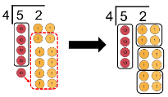  e.g. 438 ÷ 3 = 146  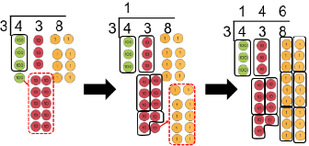  e.g. 75 ÷ 6 = 12 ½  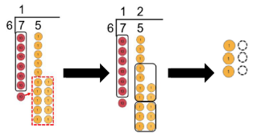  e.g. 75 ÷ 6 = 12.5  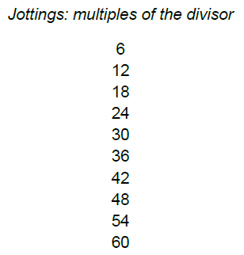  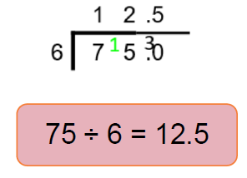  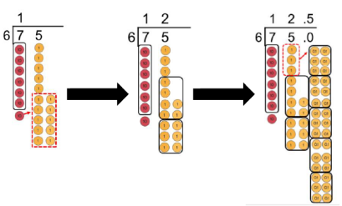 | Pictorial  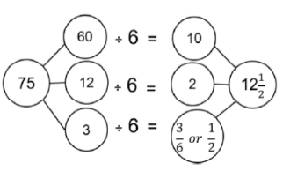  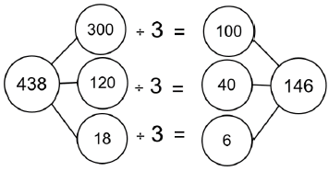  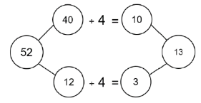 |  | Abstract  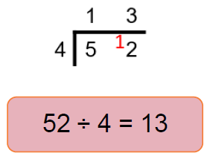  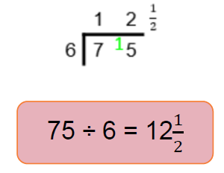  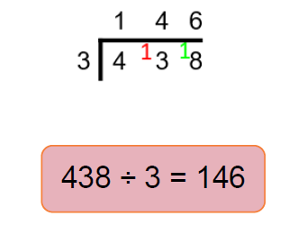
Note: Pupils are encouraged to progress to a grouping model of division. This is in preparation for 2-digit divisors and understanding fractions expressed as part of the quotient. Pupils should explore with simple division calculations to ensure that they understand the shift in structure.

Year 6
Division
Mental methods and skills  - Equivalent fractions, decimals and percentages for hundredths e.g. 35% is equivalent to 0.35 or 35/100  - Partition: use partitioning and the distributive law to divide tens and ones separately e.g.  92 ÷ 4 = (80 +12) ÷ 4 = 20 + 3 = 23  - Form an equivalent calculation e.g. to divide by 25 divide by 100 then multiply by 4; to divide by 50 divide by 100 then double.  - Use knowledge of the equivalence between fractions and percentages and the relationship between fractions and division.  - Recognise how to scale down using division e.g. if three oranges cost 24p one orange costs 24 ÷ 3 = 8p  - Converting a remainder to a decimal/fraction in context.  - Choose an efficient method.  - Divide a two-digit number by a single digit number e.g. 68 ÷ 4  - Divide by 25 or 50 e.g. 480 ÷ 25, 3200 ÷ 50.  - Double decimals with ones and tenths e.g. double 7.6 and find the corresponding halves e.g. half of 15.2  - Divide multiples of 100 by a multiple of 10 or 100 (whole number answers) e.g. 600 ÷ 20, 800 ÷ 400, 2100 ÷ 300  - Find 10% or multiples of 10%, of whole numbers and quantities e.g. 30% of 50 ml, 40% of £30, 70% of 200 g.  - Simplify fractions by cancelling.  - Identify numbers with odd & even numbers of factors & no factor pairs other than 1& themselves. |  |  | Vocabulary  As previous years plus:  Common factors  Common multiples
Written Methods and Skills
The structure of long division was first introduced in Year 3, then revisited and extended in both years 4 and 5. It is revised in year 6 with jottings used to scaffold the derivation of related division facts.
Objectives and Strategy:  Long division for numbers up to 4-digits. | Concrete  e.g. 3016 ÷ 13  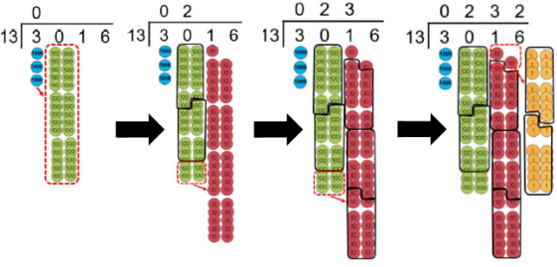 | Pictorial  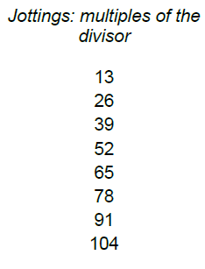 |  |  | Abstract  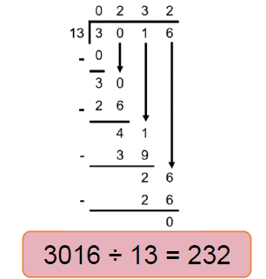
Additional Year 6 Examples:  Long division for numbers up to 4-digits – expressing quotients with fractions. | Pictorial – Jottings  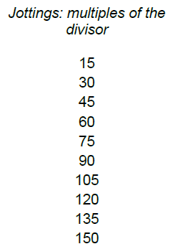  e,g. 564 ÷ 15 = 37 |  |  | Abstract  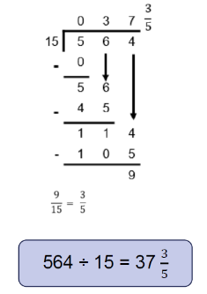

Long division for numbers up to 4-digits – expressing quotients with decimals  Pupils at all stages should be encouraged to estimate first and check their answer using a mental method. | e.g. 564 ÷ 15 = 37.6 | 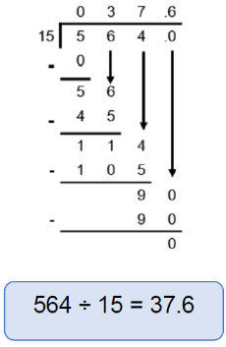
Note: These additional examples show only jottings and abstract recording. This complexity of calculation should only be introduced to pupils once they are confident in the conceptual pathway and can explain the abstract recording with reference to the concrete and pictorial models.

