
Putteridge Primary School
Play Policy

“Children need the freedom and time to play. Play is not a luxury. Play is a necessity.”
Kay Redfield Jamison

“We don’t stop playing because we grow old; we grow old because we stop playing.”
George Bernard Shaw

Rationale – Why Putteridge is doing this

Putteridge Primary School believes that all children need opportunities to play that allow them to explore, manipulate, experience and affect their environment. We acknowledge the UN Convention on the Rights of the Child, which includes the right to play, recreation and leisure (Article 31) and the right of children to be listened to on matters important to them (Article 12). Putteridge Primary School acknowledges that we have a duty to take these rights seriously and listen to children’s views on their play.

Children spend 1.4 years of their primary school attendance in playtime. This time is valuable and needs careful planning. Better play means happier children; fewer behaviour problems, a more positive attitude to school, lessons that are more effective, development of core skills, less staff time spent resolving unnecessary behavioural problems, fewer playtime accidents, happier staff and a healthier attitude to life.

Play England devised ‘The Charter for Children’s Play’ which sets out a vision for play and states that:

- Children need time and space to play at school
- Adults should let children play
- Children value and benefit from staffed play provision
- Children’s play is enriched by skilled playworkers
- Children sometimes need extra support to enjoy their right to play

Putteridge Primary School fully recognises its duties and responsibilities to support children’s playtime whilst they are here.

In June 2022 we surveyed the children and these are some of the results:

60% said there was not enough things around to play with, build or make up games.
90% said there are places around the playground where they want to play but are not allowed.
80% said there are a few places to sit but not enough.
40% said they enjoy some playtimes.
95% said they only play on the grass in the summer.
70% said that adults stop us a bit when playing.

These results highlighted the need to improve our play resources and opportunities at Putteridge Primary School.

What is play?

Play is defined as any freely chosen activity that a child finds satisfying and creative. It may or may not involve equipment or other people. We believe play has many benefits, including:
- Play is critical to children’s health and wellbeing, and essential for their physical, emotional, social, spiritual and intellectual development.
- Play enables children to explore the physical and social environment, different concepts and different ideas.
- Play enhances children’s self-esteem and their understanding of others through freely chosen social interactions, within peer groups, with individuals, and within groups of different ages, abilities, interests, genders, ethnicities and cultures.
- Play requires ongoing communication and negotiation skills, enabling children to develop a balance between their right to act freely and their responsibilities to others.
- Play enables children to experience a wide range of emotions and develop their ability to cope with these, including sadness and happiness, rejection and acceptance, frustration and achievement, boredom and fascination, fear and confidence.
- Play encourages self-confidence and the ability to make choices, problem solve and to be creative.
- Play maintains children’s openness to learning, develops their capabilities and allows them to push the boundaries of what they can achieve.

Commitment
- Putteridge Primary School is committed to ensuring high quality and sustainable play opportunities are available for all children regardless of their needs and abilities. Inclusive play is achieved by offering carefully considered outdoor spaces that offer a real choice of accessible play opportunities.

- We believe that play has a vital role in promoting children’s happiness and wellbeing. It creates children who are independent, confident, resilient, imaginative, adaptable, social and able to assess risks. Changes in society and culture have led to a decline in play opportunities; our school grounds provide a crucial place for children to experience self-initiated play.

Putteridge Primary School will:

- Provide children with a play setting which is stimulating, challenging and helps develop a lifelong love of learning.
- Allow children to take risks in a secure and supportive environment.
- Provide children with a range of play opportunities that will support their learning as well as develop confidence and resilience.

Putteridge Primary children will have the opportunity to:

- Feel happy, safe and secure
- Question, choose, evaluate, pose opinions and discuss rationally
- Develop social, communication and language skills
- Build resilience, confidence and a positive self-image
- Be creative and imaginative
- Be independent and take responsibility for themselves and others
- Develop problem solving skills
- Improve their physical development, co-ordination and fitness

Benefit
Putteridge Primary recognise that this is a change in direction for children’s play opportunities within the school environment. We acknowledge that whilst there are risks involved with this, the benefits to the children’s physical and mental wellbeing and development far exceed these.
‘Children need and want to take risks when they play. Play provision aims to respond to these needs and wishes by offering children stimulating, challenging environments for exploring and developing their abilities. In doing this, play provision aims to manage the level of risk so that children are not exposed to unacceptable risks of death or serious injury.’ Play England’s Charter for children’s play.
In keeping with our Health & Safety Statement of Intent and associated policies and procedures, we are committed to promoting health and safety and wellbeing. This is achieved through a risk management approach that balances benefits and risks and regular reviews and monitors as activities and associated risks change.
Risk
This policy recognises that risk taking is a fundamental part of children’s play and learning, and of all environments in which children and young people legitimately spend time at play. Through taking risks, children build their capabilities, explore their emotions, expand their horizons, and test boundaries. They also gain practical experience of taking responsibility for their safety.
Putteridge Primary adheres to the Health and Safety Executive guidance document ‘Children’s Play and Leisure – Promoting a Balanced Approach’ (September 2012) informing our approach to managing risk in play. It adopts a benefits/risk approach as detailed in the Play Safety Forum’s ‘Managing Risk in Play Provision’ Implementation Guide (2012) which states: ‘Play is great for children’s well-being and development. When planning and providing play opportunities, the goal is not to eliminate risk, but to weigh up the risks and benefits. No child will learn about risk if they are wrapped in cotton wool’
In addition to standard risk/benefit assessments, the school will:
- practice dynamic risk management with children
- encouraging them to identify and manage risks in an environment where adults are present to support them
- Play Assemblies will discuss risk benefits and agree rules for play with the children when new equipment is introduced.

Health and Safety and Wellbeing: checks and physical environment
Play areas and equipment will be subject to in depth standard checks on at least a weekly basis by the play lead and the co-ordinators, who will record these checks and keep them on file.
Play coordinators will carry out a daily assessment as they prepare equipment ready for children to use particularly heavy usage items.
Staff on duty will scan equipment and will remove any damaged items and ensure they log their actions with the play coordinators.
If there is damage to any larger pieces of equipment, children will be prevented from using it and staff will inform the play co-ordinators on the day that it is noted. This will be logged and the equipment will remain out of use until it is made safe. Repairs will be logged before the equipment is used again. Where damage is significant and cannot be repaired, the equipment will remain out of use and removed from site.
Children will inform staff if they notice any damage to equipment.
Risk-benefit assessments for areas, equipment and activities will be held on file and be available for inspection. All new activities which involve potential significant risk will be subject to individual or generic assessment as part of the planning process. All previous assessments will be reviewed as and when appropriate.
It is the responsibility of the Play Coordinators on duty to act upon any concerns and to ensure that any deficiencies are rectified immediately and to report to the Play Leader as soon as possible.
Clothing
It is important that children wear appropriate clothing to be able to access the site throughout the year. Children should always come to school with a waterproof coat. In the winter, children will be expected to wear wellington boots and waterproofs on the field. The children will get dirty and this is just part of their play.

Supervision
The law requires that children in school have supervision, but for primary school playtimes there are no stated ratios. During the school day there should be one or more adults present outdoors.
At lunchtime, there will be 3 adults on FS playground, 5 adults on the KS1 playground and 7 on the KS2 playground. Play coordinators are an addition to the adults mentioned above. This is subject to change as OPAL develops and children are able to move more freely from playground to playground.
Putteridge Primary school recognises OPAL’s three models of supervision: Direct, Remote and Ranging. Except for new children in Foundation Stage, Putteridge does not believe direct supervision is possible or beneficial as it can inhibit children's play.
Supervision will take the form of remote and ranging models, where adults are allocated areas of the playground to supervise and children can quickly find an adult. This model allows adults to patrol their area of the site and gain an awareness of the kinds of play and levels of risk likely to be emerging.
All staff will follow the school’s behaviour policy during playtimes and lunchtimes, with the aim of solving any conflict by working alongside the children where possible. For further details, please see our school’s Behaviour policy.
The adult’s role in play
Putteridge Primary School recognise Play England’s Charter for Children’s Play which sets out a vision for play and states that children need time and space to play at school;
- adults should let children play;
- children value and benefit from staffed play provision;
- children’s play is enriched by skilled playworkers;
- children sometimes need extra support to enjoy their right to play.

Our approach to play is structured to enable adults to facilitate children’s play:
- the Play Leader is a member of the Senior Leadership Team and is responsible for the strategic development of play within the school;
- the Play Coordinators support, monitor and implement meaningful, enjoyable and productive child-initiated play through the Play Team;
- Lunchtime staff (playworkers) are responsible for supervising and providing a stimulating play environment for children.

Lunchtime staff (playworkers) are a channel of access to new materials and tools and they can act as a stimulus to children to explore and learn. They are available to participate in the play if invited.
It is the job of lunchtime staff (playworker) to ensure that the broadest possible range of play opportunities are available to all children - to observe, reflect and analyse the play that is happening and select a mode of intervention or make a change to the play space if needed. The Play Coordinator will support lunchtime staff (playworkers) in achieving this.
Putteridge Primary School will help children maximise the benefits of play through adults who are informed by and work to the Play England Playwork Principles:
- play enables children to explore the physical and social environment, different concepts and ideas;
- play encourages self-confidence and the ability to make choices;
- play is critical to children’s physical and emotional health, and enables them to explore and develop the balance between their right to act freely and their responsibilities to others;
- free play can have a direct positive impact on a child’s ability to reach their potential.

Staff will use and refer to ‘The Principles of Playwork’ when appropriate interventions are needed, but ultimately will strive for facilitating an environment which nurtures self-directed play.

Inclusion
Through providing a rich play offer meeting every child’s needs, we will ensure all children regardless of age, gender, race, disability or other special needs can develop and thrive, build strong relationships and enjoy school. Playworkers ensure that the play space is inclusive, supporting all children to make the most of the opportunities available in their own way.
Monitoring
The school will continue to use the OPAL audit tool and pupil survey to monitor the implementation of the play policy and action plan.
Review
This policy will be reviewed annually so we can update the policy as OPAL progresses.

Appendix 1

Play England

Charter for Play
Play is an essential part of every child’s life and is vital for the enjoyment of childhood as well as social, emotional, intellectual and physical development.
When children are asked about what they think is important in their lives, playing and friends is usually at the top of the list.
Defining play
How do we define what ‘playing’ actually means?
Our Charter for Children’s Play describes play as: ‘what children and young people do when they follow their own ideas and interests, in their own way, and for their own reasons.’
Play has also frequently been described as ‘what children and young people do when they are not being told what to do by adults’.
Having time and space to play gives children the opportunity to meet and socialise with their friends, keeps them physically active, and gives the freedom to choose what they want to do.
Research shows that play has many benefits for children, families and the wider community, as well as improving health and quality of life. Recent research suggests that children’s access to good play provision can:
- increase their self-awareness, self-esteem, and self-respect
- improve and maintain their physical and mental health
- give them the opportunity to mix with other children
- allow them to increase their confidence through developing new skills
- promote their imagination, independence and creativity
- offer opportunities for children of all abilities and backgrounds to play together
- provide opportunities for developing social skills and learning
- build resilience through risk taking and challenge, problem solving, and dealing with new and novel situations
- provide opportunities to learn about their environment and the wider community.

Evidence is also available that outlines wider benefits of play provision for families and communities, suggesting that:
- parents can feel more secure knowing that their children are happy, safe and enjoying themselves
- families benefit from healthier, happier children
- buildings and facilities used by play services are frequently seen as a focal point for communities
- it offers opportunities for social interaction for the wider community and supports the development of a greater sense of community spirit, promoting social cohesion
- public outside spaces have an important role in the everyday lives of children and young people, especially as a place for meeting friends
- parks and other green spaces are popular with adults taking young children out to play and for older children and young people to spend time together.
Summaries of the research and evidence of the positive benefits of play are discussed in detail in Play for a Change.

Children’s right to play is a human right
On 1 February 2013 the United Nations Committee on the Rights of the Child adopted a General Comment that clarifies for governments worldwide the meaning and importance of Article 31 of the Convention on the Right of the Child.
A General Comment is an official statement that elaborates on the meaning of an aspect of the United Nations Convention on the Rights of the Child that seems to require further interpretation or emphasis. The aim of the General Comment is to raise the importance of an Article and increase accountability among countries that have signed up to the Convention.
The International Play Association (IPA) provided evidence to the UN Committee on the Rights of the Child that has persuaded them there is need to clarify Article 31 – this clarification is made through the publication of a General Comment. The IPA has taken a lead role in the development of the General Comment.

Appendix 2

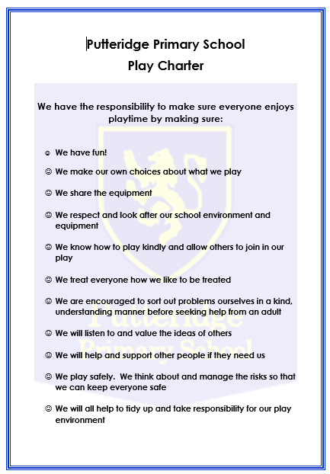

Appendix 3

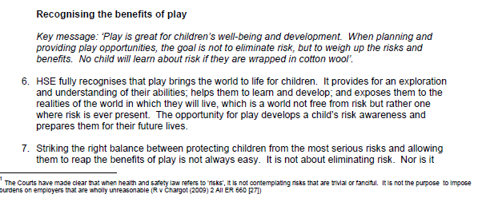
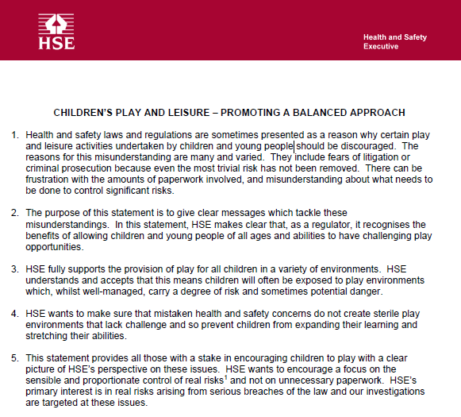

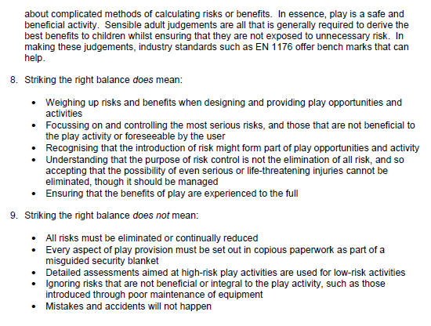
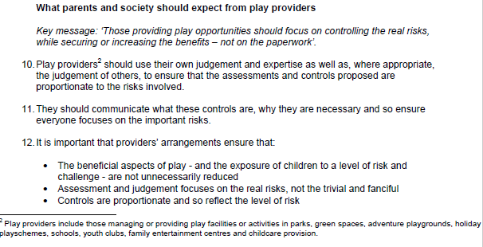

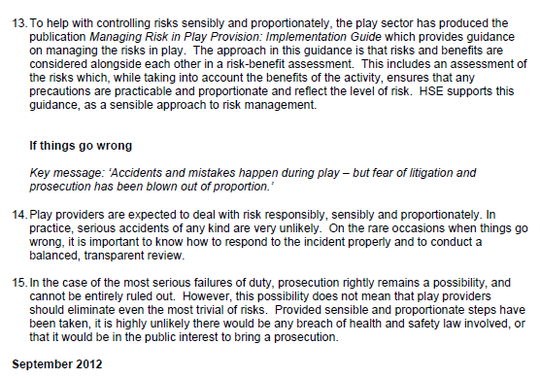

Appendix 4



