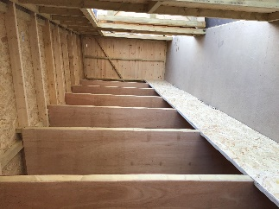
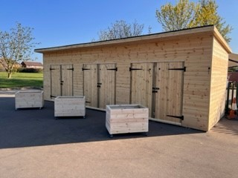
THE OPAL SHED made by 
It has been a busy Easter holiday and we finally have our OPAL shed. If you have not seen it, you will find it on the KS2 playground. We have to say a massive thank you to Hamilton Builders who took the picture from a catalogue and were able to create this for us. Inside it looks like a stable and the children have already been asking when we are getting horses! We are now starting to fill up the shed with resources for the children to use at play and lunchtime.

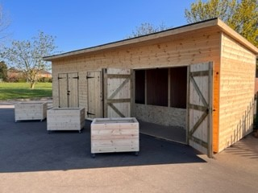

Wellies
The children have been using the mud kitchen in the Spring term. The ground is still not quite dry enough for children to use this without their wellies on. Please could children continue to bring wellies until further notice.
We would also like to use the field in all weathers but to do this, children will need wellington boots.
Finally, if children grow out of their wellies, then please could you donate them to school for our spare welly store.



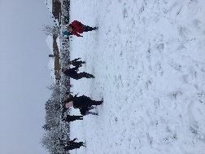
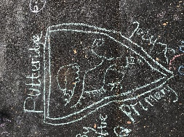
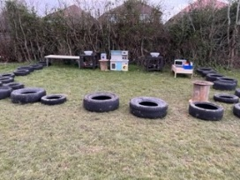
OPAL Superstars
We have introduced our OPAL Superstars play certificate where we acknowledge children’s play throughout the week.
Congratulations to Chloe, Amnah, Nikole and Bella in year 6 who found some creative ways to turn a suitcase into a royal carriage.




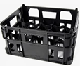
The power of playtime
There are so many benefits to following OPAL. If you would like to find out more information, then please click on the link below.
https://outdoorplayandlearning.org.uk/wp-content/uploads/2021/07/NonOpalSchool-A5-Parents-Guide-web.pdf

Sensory garden
We have now received the money from our grant application. We will start to create our garden over the summer term with support from the school council.
Outdoor Classroom Day
We will celebrate Outdoor Classroom Day on 18th May. Watch out for updates of our plans.

Donations
We are continuing to add to our loose parts resources for play. Please think carefully before throwing anything away because we can put them to good use.
At the moment we are looking for:

Hats pots
Bags pans
Old clothes for dressing up wooden spoons
Old toys chalks
Suitcases crates
Buckets
Trowels
Calling any plumbers! The children have really enjoyed playing with a construction kit which has pipes and attachments to join these together. If you have anything like this left over, then please consider donating them to school.
I will put the donations bin by the gates for easy access.

