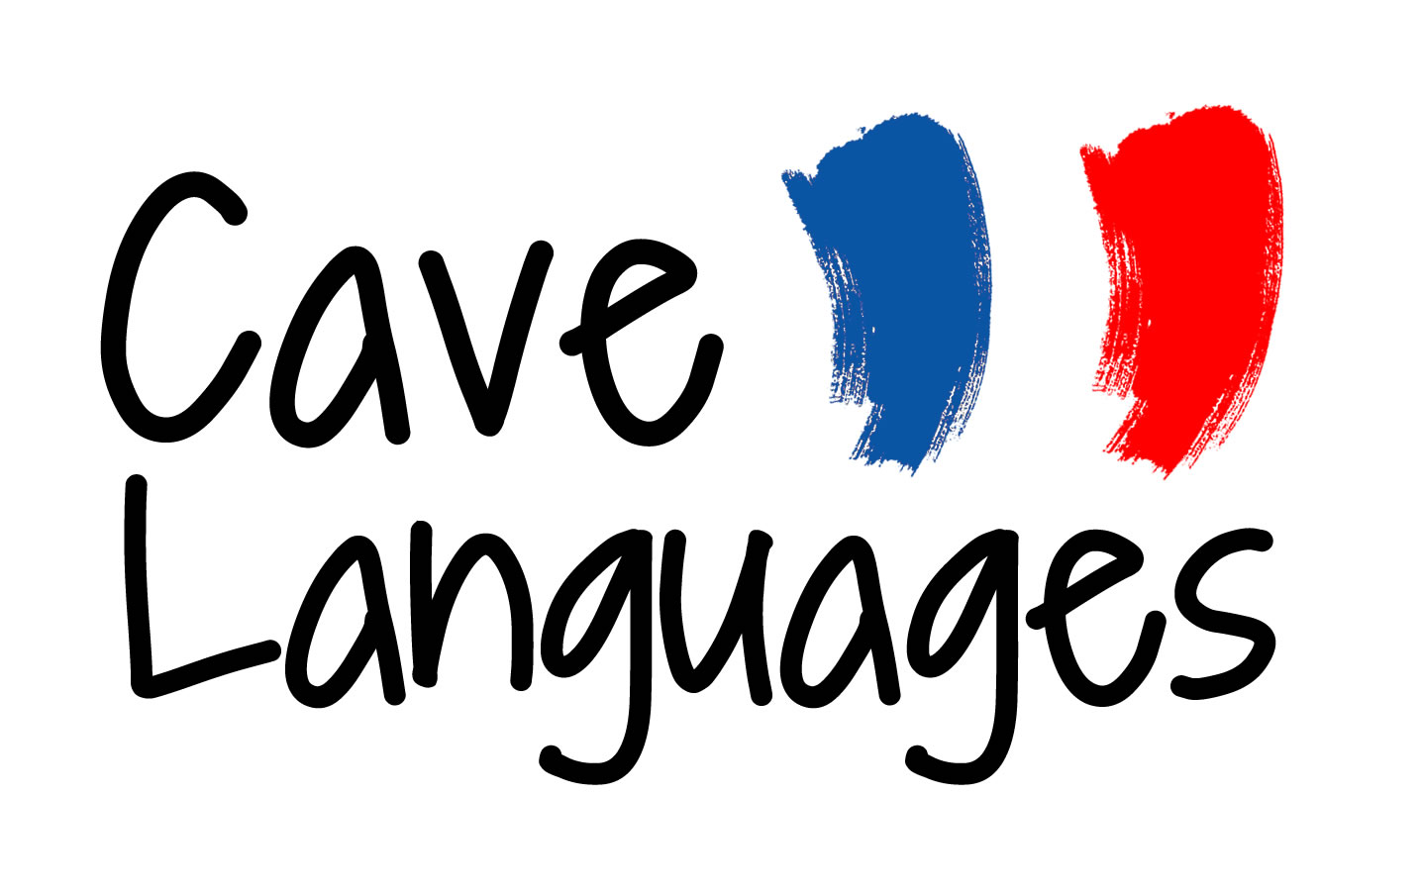
KS2 SCHEME OF WORK - OVERVIEW OF CONTENT
YEAR 3
Stage 1 Lessons 1 – 30
AUTUMN TERM  Stage 1 Lessons 1- 8  Christmas lessons 1-4 |  | SPRING TERM  New Year lessons 5-6  Stage 1 Lessons 9-18 |  | SUMMER TERM  Stage 1 Lessons 19-30
VOCABULARY | GRAMMAR | VOCABULARY | GRAMMAR | VOCABULARY | GRAMMAR
Greetings x 2  Monsieur/Madame  Classroom commands x 8  Saying how you feel x 5  Colour x 5  Christmas nouns x 7 | Indefinite article - un  Imperative vous form -er verbs | Numbers 0-6  Comment t’appelles-tu?  Je m’appelle  Consonne/voyelle | Pronouns – je/tu | Numbers 0-10  Verbs x 3  Vite/lentement  Je veux/Tu veux  S’il vous plait  S’il te plait  Merci  Pencil case items x 6 | 1st and 2nd person singular – er verbs present tense  1st and 2nd person singular – vouloir present tense  Indefinite article – un/une
STRUCTURES/FEATURES | PHONICS | STRUCTURES/FEATURES | PHONICS - GRAPHEMES | STRUCTURES/FEATURES | PHONICS - GRAPHEMES
Simple sentence - voici/et  Rising intonation - question | Introduction to the sounds of French | Question word | Silent letter rules  a/au/e + 2 cons./e in 1 syllable/eu/g/j/g before e/i/ou/r/u | Rising intonation-question  Simple sentence – 1st and 2nd person singular + verb+ adverb  Formal and informal form of you  Introduction to gender of nouns | Silent letter rules  a/an/au/c before i/ch/e + 2 cons./e in 1 syllable/é/eu/j/g before e/i/in/o/oi/r/u/z
STORIES/RHYMES/SONGS | DICTIONARY/CULTURE | STORIES/RHYMES/SONGS | DICTIONARY/CULTURE | STORIES/RHYMES/SONGS | DICTIONARY/CULTURE
Stories  Toutes les couleurs  Silence Père Noël  Rhymes/Songs  Voici ma main  Bonjour ça va | French speaking countries  Christmas traditions | Stories  Roule galette  L’automne arrive  Rhymes/Songs  J’aime la galette  2 petits oiseaux  Monsieur Pouce  Meunier tu dors? | Bi-lingual dictionary – meanings  Epiphany Festival  Dance - galette  Traditional rhymes | Stories  Je veux manger  Rhymes/Songs  Meunier tu dors  1 à 12  Une poule sur un mur  Que fait ma main?  Dans ma trousse j’ai | Traditional rhymes

YEAR 4
Stage 1 Lessons 31 - 53
Stage 2 Lessons 1 - 12
AUTUMN TERM  Stage 1 Lessons 31 - 42 |  | SPRING TERM  Stage 1 Lessons 43 - 53 |  | SUMMER TERM  Stage 2 Lessons 1 - 12
VOCABULARY | GRAMMAR | VOCABULARY | GRAMMAR | VOCABULARY | GRAMMAR
J’ai/Tu as  Dans ma trousse  Items of clothing x 5  Je mets/Tu mets  Oui/Non  Des | Gender of nouns  Plural nouns  1st and 2nd person - avoir  1st and 2nd person - mettre | C’est  Days of the week  Numbers 11-20 | Plural nouns | C’est  Ce n’est pas  Qui est-ce?  Colours x 6  De quelle couleur est-ce? | Negative - ne.. pas  3rd person singular être  Position of colour adjective
STRUCTURES/FEATURES | PHONICS - GRAPHEMES | STRUCTURES/FEATURES | PHONICS - GRAPHEMES | STRUCTURES/FEATURES | PHONICS - GRAPHEMES
Sentence with pronoun, verb and singular/plural nouns  Rising intonation-question  Elision | Silent letter rules  a/ai/c before e/c before i/ch/e + 2 cons./ e in 1 syllable/ è/ eau/ -es/eu/j/g/in/o not at end/oi/on/r/u/y | Counting nouns beginning with a consonant  Elision | Silent letter rules  a/an/c before e/ch/e + 1 cons./e + 2 cons./ei/en/ eu/j/i/in/o not at end/ on/ou/qu/r/u/un/z | Short positive and negative sentences  Rising intonation- question  Question word  Formation of negative sentence  Elision  Liaison | Silent letter rules  a/an/c before e/e + 1 cons./e in 1 syllable/e + 2 cons./en/ eu/g before e/i/o not at end/ ou / qu/r/s between vowels/un/
STORIES/RHYMES/SONGS | DICTIONARY/CULTURE | STORIES/RHYMES/SONGS | DICTIONARY/CULTURE | STORIES/RHYMES/SONGS | DICTIONARY/CULTURE
Stories  Je m’habille et je te croque  Rhymes/Songs  Beau front  Eiffel Tower | Eiffel Tower | Stories  Par une sombre nuit de tempête  Rhymes/Songs  11 à 20  Days of the week  1,2,3 je m’en vais au bois | Bi-lingual dictionary - meanings  2 times table | Rhymes/Songs  De quelle couleur est-ce?  Une souris verte | French speaking countries in Europe

YEAR 5
Stage 2 Lessons 13 - 51
AUTUMN TERM  Stage 2 Lessons 13 - 24 |  | SPRING TERM  Stage 2 Lessons 25 - 39 |  | SUMMER TERM  Stage 2 Lessons 40 - 51
VOCABULARY | GRAMMAR | VOCABULARY | GRAMMAR | VOCABULARY | GRAMMAR
Tu/Vous  Qu’est-ce que c’est?  C’est un  Masculine animal nouns  x 12  Feminine animal nouns x 9 | Gender of nouns  Position of colour adjectives  Agreement of adjectives in singular  3rd person singular - être | Ce sont des  Petit/Grand  Je suis/Je ne suis pas  Tu es  Assez/très  Il y a /Qu’est-ce qu’il y a?  Dans le sac/ le jardin/ placard/la boîte  Le,la,l’,les  Mon, ma, mes | 1st/2nd/3rd person singular and 3rd person plural – être  Plural nouns  Position of adjectives of size  Agreement of adjectives in singular and plural with nouns and pronouns  Possessive adjective  Definite article | Er Movement verbs x 6  Le,la,l’,les  Pets x 8  Family members x 4  J’ai/Je n’ai pas de/Tu as  Je veux  S’appeler  Aimer  Qui  Mais | Imperative – er verbs – vous form  1st, 2^{nd,} 3rd person singular and plural – er verbs  Definite article  1^{st,}2nd person singular – avoir  Negative – ne..pas + de  Pronouns – 1st and 2nd person singular,3rd person singular and plural
STRUCTURES/FEATURES | PHONICS - GRAPHEMES | STRUCTURES/FEATURES | PHONICS - GRAPHEMES | STRUCTURES/FEATURES | PHONICS - GRAPHEMES
Formal and informal – you  Question form using rising intonation  Question word  Sentence with noun and colour adjective  Liaison  Elision | Silent letter rules  a/â/ai/an/c before e/ ch/e in 1 syllable/e + 2 cons./e + final t/è/ei/ i/ ien/ill after vowel/ gn/ ll after i/o not at end/ on/ou/ qu/r/rr/s between vowels/th/u/ un/ | Sentence with an adverb of place size adjective, noun and colour adjective  Question word sentences  Agreement of possessive adjectives  Liaison  Elision | Silent letter rules  a/ai/an/c before e/ch/e in 1 syllable/e + 1 cons./e + 2 cons./e + final c/è/é/ei/ en/ -es/-ez/g/g before e/ gn/i ien/ill after vowel in/ j/ll after i/oî/on/ou/qu/r/s betweenvowels/th/u/un/y | Sentence with adjectives and nouns and a subordinate clause  Question with rising intonation  Elision | Silent letter rules  a/ai/an/au/ch/e in 1 syllable/e + 1 cons./è/é/ -es/er/-ez/g before e/i/ien/ ill/in//j/o not at end/ oeu/oi/on/qu/r/s/u/un/
STORIES/RHYMES/SONGS | DICTIONARY/CULTURE | STORIES/RHYMES/SONGS | DICTIONARY/CULTURE | STORIES/RHYMES/SONGS | DICTIONARY/CULTURE
Stories  Va t’en grand monstre vert  Rhymes/Songs  Savez-vous planter les choux?  Mon Ane  Une souris verte  Léon le caméléon | Bi-lingual dictionary – gender of nouns  Traditional song | Rhymes/Songs  Des amies sages  Alouette  Petit ballon  Il court le furet  Trois petits chats  Valentine’s poem | Bi-lingual dictionary – nouns in singular and plural  Traditional songs and game | Stories  Bon appétit Monsieur Lapin  Qui conduit?  Pourquoi? | Bi-lingual dictionary – meanings, gender and nouns in plural

YEAR 6
AUTUMN TERM  Shape Book – 5 lessons  Colour Poem – 5 lessons |  | SPRING TERM  Monster description – 8 lessons  Mini-book ‘Moi et toi’ – 10 lessons |  | SUMMER TERM  Guess the animal – 7 lessons  Ours brun story – 6 lessons
VOCABULARY | GRAMMAR | VOCABULARY | GRAMMAR | VOCABULARY | GRAMMAR
C’est  Shapes – un rectangle, un triangle, un cercle, un carré  Grand/petit  Colours x 11  Comme  Le, la, l’ les | Indefinite article  Gender of nouns  Position of adjectives  Size adjectives before noun  Agreement of adjectives in singular  Definite article  Singular and plural nouns | Parts of the body x 15  Animal parts x 3  Colours x 11  Grand, petit, gros, long  Frisé, court, mi-long  Fort, drôle, intelligent  S’appeler  Pets x 8  Un frère, un demi-frère, une soeur, une demi-soeur  Mon anniversaire  C’est, ou, très, assez, mais  Months of year  Aimer  Numbers 1 - 31 | Indefinite/definite article  Singular and plural nouns  1st, 2nd,3rd person singular/plural – avoir/être  Position of colour adjectives and adjectives of size  Adjectival agreement singular and plural  Pronouns 1st ,2nd, 3rd person singular and 3rd person plural  Negative ne..pas + de  Er verbs – 1st ,3rd person singular and 2nd person singular and plural  Possessive adjective – 1st person | Er Verbs x 7  C’est/Qui  Animals x 12  Habitats x 9  Animal parts of body x 4  Avoir/Être  Grand, petit, joli, gros, jeune, long, beau, vieux  Colours x 11  Dans/Par ici | Infinitive  Qui – relative clause  3rd person singular – er verbs/avoir/être  Negative – ne…pas + de  3rd person singular – avoir/être  Position of adjectives  Agreement of adjectives  3rd person plural – er verbs
STRUCTURES/FEATURES | PHONICS - GRAPHEMES | STRUCTURES/FEATURES | PHONICS - GRAPHEMES | STRUCTURES/FEATURES | PHONICS - GRAPHEMES
Question – rising intonation  Elision  Liaison | Silent letter rules  a/an/au/c before e/e in 1 syllable/e + 1 cons./e + 2 cons./é/-es/eu/g/g before e/i/j/o/o not at end/oi/on/ou/r/s between vowels/u/un/ | Sentence with adjective of size, noun and colour adjective in singular and plural, positive and negative  Question form – rising intonation  Question words  Familiar and formal use of you  Elision/Liaison | Silent letter rules  a/â/ai/ain/am/an/c before i/ch/e in 1 syllable/e + 1 cons./e + 2 cons./è/é/ê/-ed/ei/em/en/ -es/-er/eu/-ez/g before e/i/ ien/in/ j/ll after i/o not at end/o/ô/ oeu/oi/on/ou/oû/qu/r/s between vowels/u/un/y | Sentence with noun and adjectives and subordinate clause with verb in 3rd person singular and preposition  Elision | Silent letter rules  a/ai/an/ch/e in 1 syllable/e + 1 cons./e + 2 cons./é/ei/en/ -es/-er/eu/g/g before e/gn/i/il/ ill after a vowel/in/o not at end/on/ou/qu/r/s between vowels/u/y
STORIES/RHYMES/SONGS | DICTIONARY/CULTURE | STORIES/RHYMES/SONGS | DICTIONARY/CULTURE | STORIES/RHYMES/SONGS | DICTIONARY/CULTURE
Stories  Qui conduit?  Songs  Le/la song | Bi-lingual dictionary – find nouns in French and gender | Stories  Va-t’en grand monstre vert  Songs  Tête, épaule, genou.. etc.  Mon monstre  Une patate | Bi-lingual dictionary for gender, plural nouns and adjectives  French handwriting | Stories  Ours brun | Bi-lingual dictionary for nouns and gender, –er verbs, prepositions, adjectives
Phonics letters in bold = new in scheme

