Putteridge Primary
School



Social Media Policy

Therapeutic Thinking Approach to Positive Behaviour Policy
September 2025

Last reviewed:
Next review due by: September 2027

Section 1: Vision and Values

At Putteridge Primary School, we aim to create an effective environment for learning in which everyone feels cared for and valued, and one that encourages all children to achieve the highest standards through:
- The provision of a safe and nurturing environment
- The provision of a broad, balanced and imaginative curriculum
- High expectations
- An ethos based on respect for themselves and all individuals
- Equal opportunities

Our approach to behaviour comes from our belief that children learn best when they feel safe, calm, happy and are able to self-regulate their emotions. Putteridge Primary School promotes ‘valued’ behaviour and all adults work collaboratively in this approach.

Our policy is underpinned by the principles of Therapeutic Thinking. This approach focuses on supporting children's emotional wellbeing and mental health. It also develops an understanding of tailoring responses to children who may communicate through their behaviours. Therapeutic Thinking uses a range of resources to analyse an individual’s behaviour to better understand their needs. This enables better planning for the child, their class and the wider setting. The approach helps staff to understand children’s behaviour and respond in an inclusive way that promotes change.

What is Therapeutic Thinking?
When we use a therapeutic approach:
- We analyse behaviour rather than moralise about it
- We look for the root causes from feelings and experiences
- We model therapeutic practices with all children, adults in school and parents or visitors from outside
- Our language is chosen carefully from universal scripts to be outcome and resolution focused rather than emotive

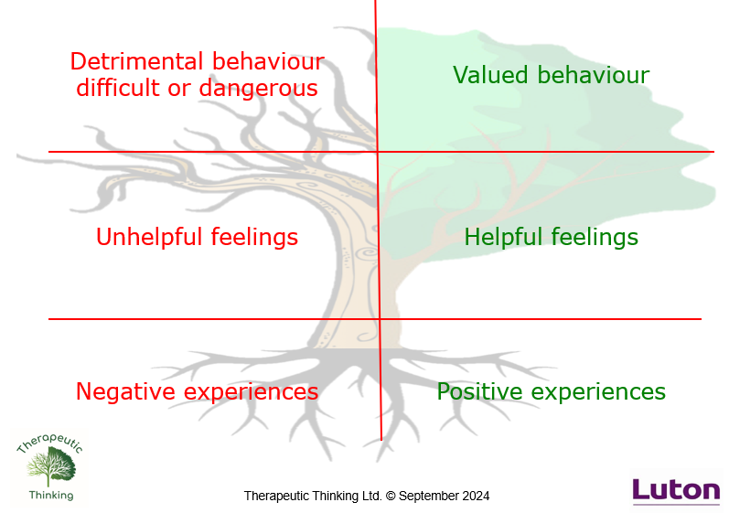
The Therapeutic Thinking approach challenges the concepts of ‘bribes and sanctions’ frequently used to manage behaviour which often results in children and young people only following instructions because they will 'get something’ for doing so. Instead, the approach seeks to foster the independence of children and young people by teaching them how to develop internal discipline. The aim is that they are always able to behave in a positive way, without the need for adults to manage this.
ROOTS & FRUITS

At Putteridge Primary School, we firmly believe that:

- Positive experiences create helpful feelings

- Helpful feelings create valued behaviour

Negative experiences create unhelpful feelings

Unhelpful feelings create detrimental behaviour

Aims of the Therapeutic Approach
At Putteridge Primary School we have high expectations of behaviour and we work together to create an environment in which everyone feels respected, valued and fairly treated.
We aim to:
- Provide a calm, purposeful and happy atmosphere within school
- Foster positive, caring attitudes towards everyone where achievements at all levels are recognised and valued
- Teach valued behaviours so that pupils make progress
- Develop an understanding of behaviour as a form of communication
- Encourage increasing independence and self-discipline so that each child learns to accept responsibility for their own behaviour
- Have a consistent approach to behaviour throughout the school with parental co-operation and involvement
- Make boundaries of acceptable behaviour clear to ensure safety
- Support inclusion of those pupils who display difficult or dangerous behaviours in all school activities
Section 2: Supporting all Learners

At Putteridge Primary School we provide children with what they need to succeed in their learning. We endeavour to create a culture which inspires a love of learning through emotional and social intelligence and a responsibility of self-discipline and respect for others.

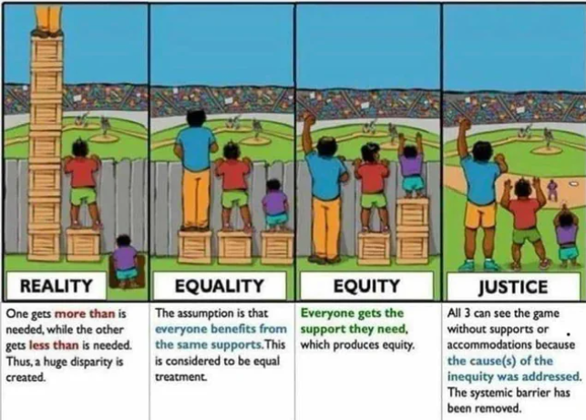

Equality is treating everybody the same. Equality aims to promote fairness but it can only work if everyone starts from the same place and needs the same help.
Equity is giving everyone what they need to achieve success. At Putteridge Primary School we advocate for each child to receive the resources, experiences, appropriate interventions and support in their learning to achieve their full potential.

Everyone in our school is responsible for the behaviour and discipline of our pupils and must ensure that continuity exists between all staff. Where continuity exists, so does security. All children in school need to know the rules of our school and, indeed, to have played a part in creating them.

Key Principles
- Behaviour is a form of communication
Approaches to emotional wellbeing and behaviour are viewed in a non-judgemental, curious and empathetic way.
- Not all behaviours are a choice
Children and young people with poor emotional wellbeing are regarded as vulnerable rather than troublesome. It is accepted that some behaviours can be driven by a communication need, a perceived outcome or a biological reaction to overwhelming feelings.
- Behaviours can change and improvement can be secured
Expectations of pupils’ emotional wellbeing and behaviour are high but realistic and grounded in a belief that change can be affected and improvements secured
- Clear boundaries are paired with an individual graduated response where needed
A nurturing and structured environment is used to keep children safe. A clear, well communicated behaviour policy is used to set standards and create consistency. The policy enables reasonable adjustments for clear plans where adaptation from the policy is essential to meet a child’s needs including educational, mental health and other needs or vulnerabilities.
- Children may develop at different rates academically and emotionally
It is accepted that there may be a difference between a child’s chronological age, their academic achievement and their emotional literacy. Children achieving well academically may well still require differentiated planning.
- Children are supported to develop internal discipline / self-regulation and resilience
A variety of feedback, reward or consequence systems are used to develop children as resilient, independent learners with positive emotional wellbeing and behaviour
- A commitment to equality and equity
Each child receives appropriately differentiated resources to enable them to access school, learning and social opportunities equally. The Equalities Act 2010 recognises that some children may need additional support to increase positive emotional wellbeing and support behaviour
- A commitment to exclusion reduction
Permanent exclusions are used only as a last resort. There is a clearly defined rationale for exclusion linked to an understanding of vulnerable groups such as those affected by attachment, adverse childhood experience, trauma, mental health and protected characteristics such as disability or race.
- Engagement of families, outside agencies and the wider community is sought when planning support for children
There is proactive engagement with families, outside agencies and the wider community to promote consistent support for children. Parents and carers are key in promoting positive emotional wellbeing. These adults have an informed perspective and their insights are of value in informing planning and decision-making. It is statutory for schools to have a behaviour policy.

Our Golden Rules:
We, the children, teachers, support staff, lunchtime supervisors, parents and Governors, aim to make our school a happy and safe place by following these Golden Rules: (Appendix 3)

- We are kind and helpful – we don’t hurt anybody’s feelings
- We are gentle – we don’t hurt others
- We listen – we don’t interrupt
- We work hard – we don’t waste our own or others’ time
- We are honest – we don’t cover up the truth
- We look after property – we don’t waste or damage things

Class Charter
Each class devises its own charter at the beginning of the school year. The children, along with the teacher discuss the rights that children agree are essential for the smooth running of their class. These form the class charter which is then displayed on the wall. This grows and changes throughout the school year as circumstances require. Children are expected to be able to understand what valued and detrimental behaviours are and be able to follow the charter.

How can we teach behaviour?
Our school behaviour curriculum defines the expected behaviours in school, rather than only having a list of prohibited behaviours. It is centred on what successful behaviour looks like and defines it clearly for everyone in our school community.

We believe that behaviours have a function and are a form of communication. One behaviour may have more than one function linked to: sensory, escape, avoidance, attention or tangible gain.

EYFS / KS1 / Y3 Learning Crew
There are 10 characters who identify the learning attributes needed to be a successful learner. They help children understand how they learn and make the attributes tangible. Children are expected to work to the best of their ability and allow others to do the same.











Busy Caring Dependable Empathetic Friendly Kind Mindful Polite Thoughtful Wise
Bee Cat Dog Elephant Frog Kangaroo Monkey Penguin Tortoise Owl

Playtime
Playtimes are supervised by teachers and support staff who encourage children to play well together and to form good relationships with their peers. The staff closely monitor the children and follow the procedures set out under the detrimental behaviour section when behaviour is causing a concern.

Lunchtimes
At dinner times, supervising staff interact fully with the children and are actively engaged in playing games with them, encouraging valued behaviour through positive play supported by the Play Charter drawn up as part of the OPAL scheme. They monitor behaviour on the playground and in the halls and report any concerns to the class teacher or SLT if relevant. All such concerns are recorded on CPOMs. The supervising staff abide by the school’s Golden Rules and follow the procedures set out under the detrimental behaviour section where behaviour is causing a concern. It is the responsibility of the lunchtime staff to follow the principles of the restorative approach and take responsibility for any relevant consequences to behaviour.

Therapeutic Classroom Management
All of the children who attend this school must feel valued and that they, as individuals, have a part to play.

This can be realised in many ways, not least by encouraging each child to feel that they an important part of the community of the school and that other people e.g. siblings, peers, staff, parents/carers, visitors and governors depend on them to behave in a mature, well-mannered and respectful way. Of course, this is not a one-way process and children need to see adults in school as models of outstanding behaviour.

Creating the right atmosphere in school arises from good inter-personal relationships. Parents, carers, visitors, governors, staff and children must treat each other with a level of mutual respect.

At Putteridge Primary School, we believe in recognising valued behaviour and developing every child’s confidence and self-esteem, along with their emotional literacy. Children need to feel secure and good about themselves in order to help them treat others with consideration and respect. We make every attempt to focus on the positive rather than the negative behaviour and class teachers use positive management strategies.

Roles and Responsibilities
The staff within our school exercise the following strategies to promote valued behaviour and positive attitudes:
- We are positive role models of the behaviour we are expecting – being warm and welcoming / positive in gestures and body language
- We ensure all pupils are actively listening when speaking to the class – we wait until all are listening, using routine strategies to approach this (a quieter voice encourages better listening). We may make adjustments for some
- We are clear about our learning objectives and keep our lessons pacy, providing adaptations and support where necessary
- We use non-verbal signals and gestures wherever possible to gain attention, praising good role-models
- We are fair and consistent
- We give private praise that is specific
- We encourage children to be responsible for their own behaviour
- We form good relationships with parents and carers so that children can see that the key adults in their lives share a common aim
- We make links to the Learning Crew and Class Charter

Children are responsible for:
- Following their class charter
- Following the Golden Rules
- Taking responsibility for their own actions
- Showing respect for each other
- Taking pride in their learning and aspiring to be like the Learning Crew if they are in EYFS or KS1
- Valuing each other’s opinions

Parents are responsible for:
- Accepting, contributing to and supporting the school’s code of behaviour and therapeutic approach for staff and children
- Accepting responsibility for the conduct of their children and offering encouragement or consequences when appropriate
- Agreeing to and signing the Home School agreement when their child joins the school
- Liaising about matters which affect their child’s happiness, progress and behaviour by keeping the school well informed about situations at home that could affect their child’s behaviour in school and attending meetings when requested.

Section 3: Valued Behaviours

Valued behaviour at Putteridge Primary School is defined as that which is positive, helpful and values social acceptance. It creates helpful feelings in self and others.

Valued behaviour is characterised by a concern for the rights, feelings and welfare of other people. This behaviour benefits other people in society, e.g:
- Positive relationships and interaction with peers and adults (tone of voice, body language);
- Acknowledgement of own feelings, using positive language to support their needs (‘I need help’, ‘I’m finding this tricky’, ‘I felt cross when I got that wrong’);
- Identify, understand and accept mistakes as learning opportunities and using growth mindset to persevere and challenge themselves to complete the task;
- Identify, reflect and repair anti-social behaviour choices;
- Respects the right of themselves and others to learn and their responsibility to ensure their behaviour choices don’t negatively impact this.

Our Behaviour Curriculum
At Putteridge Primary School we teach behaviour as we would any other area of our curriculum. We manage the development of internal discipline using an approach based on self-direction and self-motivation.

We teach behaviour through:
- Building trusting relationships with children. The more we know about the child, the more therapeutic we can be. Having positive relationships with children is the most effective way of ensuring a happy and engaging learning environment.
- Role-modelling – using words and actions that mirror the responses we are trying to encourage in children;
- Consistency in approach – working out the best way to support each individual child and ensure that interactions with that child are consistent;
- Positive Phrasing – Disempowering challenging behaviour by offering positive phrasing, limited choices and appropriate consequences using minimal language;
- Scripts and routines – using agreed words and actions which are likely to be most effective in achieving the desired outcome for an individual;
- Planning – making sure that responses to likely detrimental behaviour are planned for in advance to ensure that people know what to do and are not taken by surprise. Example tools to support this are: ‘Roots & Fruits’, inclusion circles and behaviour plans.
- Reward and positive reinforcement
- Feedback and recognition - not just celebrating the things that are expected;
- Comfort and forgiveness – understanding and know that we will do it differently tomorrow;
- Restorative practice – follow up the behaviour; its impact and consequences at the appropriate time.
- Exploration of monthly values: Respect, Trust, Tolerance, Responsibility, Co-operation, Hope, Perseverance, Honesty, Patience, Kindness, Success and Optimism

All staff are expected to acknowledge, promote and consolidate valued behaviours with the children. There are a number of ways in which staff achieve this.

Positive reinforcement ideas
- Non-verbal examples are good for not interrupting the learning, e.g. thumbs up, point to your own smile
- Words of encouragement – be specific and tell them what you are praising them for (praise for specific small valued behaviours increases the chance of others following), e.g. ‘I have noticed…’
- Stickers – can be given for particular encouragement
- Peers encouraging each other
- Merits (for class or homework only)
- Certificates
- Inform parents – verbally at pick up time, phone call, postcards and notes home

External discipline is controlling behaviour; internal discipline is teaching behaviour. To create change we need to understand, not simply suppress, the behaviour. We manage the development of internal discipline to gradually replace external discipline – using an approach based on self-direction and self-motivation to replace control measures such as bribery, punishment and control. We have no public methods of tracking behaviour that risk creating negative feelings – children cannot publicly see the judgement of staff and we have adopted private levels of praise. Predominantly, children expect feedback and verbal recognition of support.
Whoops Poster
If children depart from valued behaviours then adults in the class will support them using the Whoops Poster. This is a sequential list of steps that adults will work through with a child until valued behaviours are back in place

Positive Phrasing
Interactions will be assertive, directive and non-confrontational (stick to what/where and when and use this to focus and re-focus on appropriate behaviour choices.

Outlined below are examples of how we address children:
Always use inclusive pronouns to build the team idea…We / Us / Our etc.
“At our school / in our class / at Putteridge…”

Interactions – Describe and Direct
Don’t ask ‘can you / will you?’ – These often result in a ‘no!’
Instead:
- Describe what you see
- Direct what is required

Examples of Negative Phrasing (not expected) | Examples of Positive Phrasing (expected)
“Why are you talking?”  “Why are you fiddling with that?  “Don’t run!”  “Don’t play with that pencil.”  “Stop staring out of the window/daydreaming.” | “X, you are talking. This is listening time. Please stop.”  “X, you are fiddling with…That is distracting. You need to…”  “Walk, thank you.”  “Put the pencil down, thank you.”  “Looking and listening – eyes this way…thank you.”

Limited Choice
- Where shall we talk, here or in the library?
- Are you going to sit on your own or with a group?
- Are you starting your work with the words or a picture?

Disempowering the behaviour
- You can listen from there
- Come back in to the room when you are ready
- We will carry on when you are ready

The de-escalation process (Child in Crisis)
Putteridge staff recognise that at times children find their emotions difficult to manage, leading them to react in an uncharacteristic way. In these situations, we refer to the child as being ‘in crisis’ rather than saying ‘kicking off’, ‘stropping’ or ‘playing up’. Staff will follow the process below to ensure that everyone’s wellbeing is respected and the child can return to a calm state of mind as quickly as possible.

De-escalation Principles | De-escalation Script
Use the child’s name | Child’s name
Acknowledge their right to their feelings | I can see something has happened
Tell them why you are there | I am here to help
Offer help | Talk and I will listen
Offer a ‘get out’ (positive phrasing) | Come with me and…

Further examples and scripts can be found in Appendix 7

Zones of Regulation
We also teach the Zones of Regulation which is a SEMH approach used to teach self-regulation by categorising all the different ways we feel and states of alertness we experience into four coloured zones. The Zones framework provides a toolkit for children to become aware of and independent in controlling their emotions and impulses, manage their sensory needs and improve their ability to resolve conflicts.

The Four Zones: Our feelings and states, determines our Zone.
The Red Zone is used to describe extremely heightened states of alertness and intense emotions. A person may be elated or experiencing anger, rage, devastation or terror when in the Red Zone.
The Yellow Zone is also used to describe a heightened state of alertness and elevated emotions; however, one has more control when they are in the Yellow Zone. A person may be experiencing stress, frustration, anxiety, excitement, silliness or nervousness when in this zone.

The Green Zone is used to describe a calm zone of alertness. A person may be described as happy, focused, content or ready to learn when in the Green Zone. This is the zone where optimal learning occurs.

The Blue Zone is used to describe low states of alertness such as when one feels sad, tired, sick or bored.

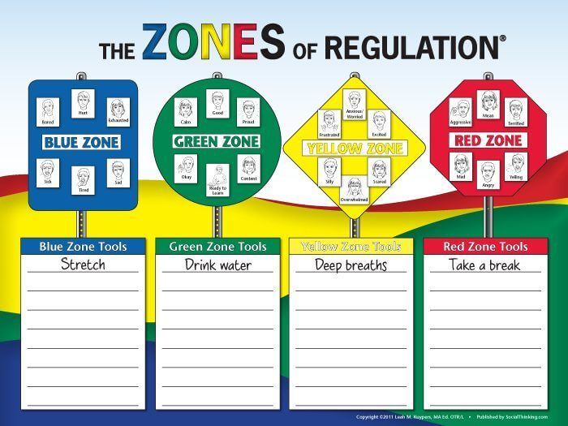
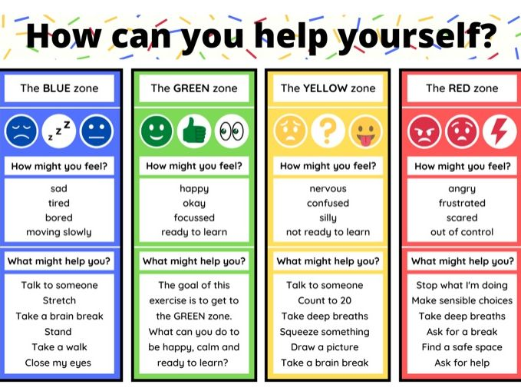

Section 4: Unsocial Behaviour

At Putteridge Primary School, unsocial behaviour is defined as where children are unwilling or unable to behave socially in the company of others, but not to the detriment of themselves or others. For example:
- Not seeking to associate with others but not to their own or others’ detriment
- Not doing as instructed or dictated but not to their own or others’ detriment

These behaviours may include, but are not limited to:
- Leaving their table without permission
- Leaving the carpet during input/story without permission
- Refusing to complete work set
- Refusing to get changed for PE
- Choosing to do a different activity from that the rest of the class are doing (e.g. reading, drawing on whiteboard etc.)
- Rocking on their chair
- Calling out / talking to a friend
- Not listening to instructions
- Playing / fiddling with equipment

We must listen to quiet unsocial behaviour with as much understanding as we do loud demanding behaviour. Children may choose to communicate with quiet non-compliance as a natural communication style of intuitively quiet people.
In these cases, staff should interpret unsocial behaviour as a communication of negative feelings (perhaps needing help, attention or that they are bored/impatient), therefore adapting or supporting to meet the needs of pupils
All staff are responsible for addressing unsocial behaviour. No unsocial behaviour should need WLT or SLT support unless it becomes persistent and disruptive, therefore escalating to detrimental behaviour.

Section 5: Detrimental Behaviour

At Putteridge Primary School, detrimental behaviour is defined as that which causes harm to an individual, a group, to the community or to the environment. Such behaviour is likely to cause injury, alarm or distress.

Difficult Detrimental Behaviour: Behaviour that is detrimental but not dangerous. Difficult behaviour should be acknowledged in terms of context (e.g. ‘X’ continually shouting out is difficult when engaged in a group teaching activity).

Dangerous Detrimental Behaviour: Behaviour that is detrimental and will predictably result in injury or harm (including harm to self or others, damage to property or behaviour that would be considered criminal if the person was the age of responsibility [10 years], such as racist abuse). The behaviour described as dangerous will be supported by evidence of severity and frequency of outcomes e.g. 3 children required first aid for minor bruising as a result of ‘X’s kicking. In the table below are some examples of difficult and dangerous behaviours.

Difficult Detrimental Behaviour | Dangerous Detrimental Behaviour
Distracting others from learning by shouting, making noises, banging  Invading personal space  Disruptive behaviour in assembly  Ripping work or damaging displays  Swearing  Answering back/mimicking  Name-calling  Lying  Throwing small equipment (rubbers, sharpeners) Stealing  Damage to property  Refusing to carry out an adult’s request | Not keeping themselves safe  Physically harming another child/adult  Damaging property and/or resources  Playing roughly  Leaving the school building  Spitting (directly at another)  Throwing large equipment or furniture  Verbal bullying / abuse

All staff are responsible for addressing detrimental behaviour. Only very frequent and persistent detrimental behaviours will require WLT or SLT intervention. Responses to detrimental behaviour are outlined in Appendix 7, using scripted language to positively rephrase, limit choice or disempower the behaviour in order to facilitate a change in that behaviour. Educational consequences are also recorded.

Please be aware that all of these behaviours could be a sign of needing help or attention and pupils may be in a very heightened, anxious state – possibly due to factors outside of school – please be aware of and sympathetic to this and that their behaviour may be a cry for help.

Restorative Practice
After any detrimental behaviour has happened, an in-depth restorative de-brief with the child will take place as soon as regulation is restored in order to understand why it occurred. The purpose of this is to re-visit the experiences by re-telling and exploring the scenario with a changed set of feelings.

The aims of our restorative de-brief are to:
- Focus on the harm that has been done
- Identify how the harm can be repaired
- Look at the experiences, feelings and needs of everyone involved
- Plan to ensure conflict is less likely to happen in the future.

The purposes of a restorative de-brief:
- Explore what happened. Allow the child to tell their story and ensure they feel heard.
- Support their story with non-judgemental, accurate descriptions.
- Explore what people were thinking before, during and after the incident.
- Identify who has been affected and how.
- Consider how the relationship can be repaired.
- Plan for a different response to the same experiences of feelings recurring in the future.

The above is carried out in a differentiated, age-appropriate way that is accessible to the child.

Examples of resources that might be used:
- Social stories
- Role-play (possibly with puppets / small-world figures)
- Comic strip conversations
- Independent / adult-led reflection activities (Appendix 8)
Staff will then implement protective and educational consequences following any detrimental behaviour. This will be clearly explained to the child, setting out expectations and what will happen next:

Protective consequences: Removal of freedom to manage harm, e.g. staying in at lunchtime to keep others safe.
Educational consequences: The learning, rehearsing or teaching so the freedom can be returned, e.g. games with a small group to learn how to take turns.

Both protective and educational consequences are documented in our behaviour pathways. These will support staff as they are a map to follow but can be adapted and personalised for individual children. For example, for a child who disrupts games and playtimes, a ‘Playtime Plan’ would be put in place or an intervention to support developing prosocial behaviours when playing games. Staff may also refer to the ‘Whoops Poster’ to help the child get back on track.

There will be occasions where children’s behaviour choices require a consequence and these are carefully structured according to the behaviour (Appendix 6):

Beyond the school day
The law also gives teachers the power to support children to understand the impact of their behaviour beyond the school day. Pupils maybe reported for displaying detrimental behaviour outside of the school if it is witnessed by a staff member or other members of our school community. This could be when:
- Travelling to and from school
- A pupil is wearing school uniform
- A child is in some other way identifiable as a pupil at the school
- A pupil poses a threat to another pupil or a member of the public
- Behaviour could adversely affect the reputation or orderly running of the school
The school will also use this to respond to detrimental behaviour displayed by pupils in the care of their parents whilst on the school’s premises. Educational and / or protective consequences may be put in to place in order to address this in line with the policy.

An example of a protective consequence may be to withdraw the right for a Year 5 or 6 child to walk to and from school unaccompanied until a suitable time to allow for the child to be taught how to do this safely.

Risk Management Plan
Staff will follow the Behaviour Management Flow Chart (Appendix 5) to manage the risks of detrimental behaviour. If these behaviours are regularly repeated by a child, a Risk Reduction Plan using the Therapeutic Thinking Toolkit (Appendix ?) may be put in place to support staff in managing risks and support the child in changing their behaviour. This will advise staff on how to predict and prevent behaviours, use appropriate strategies to calm and regulate the child, helping them to recognise better prosocial ways to deal with uncomfortable situations.

Our approach to physical intervention
At Putteridge Primary School, therapeutic behaviour management strategies are used and are set out in the table below to respond to difficult and dangerous behaviour. However, there may be justification where physical intervention is necessary in order to manage risk. Staff will only intervene when de-escalation strategies have been exhausted and risks are still high to the safety of either the child who is behaving in a difficult or dangerous way or to others around them. In exceptional circumstances, staff may need to use reasonable force when managing difficult or dangerous behaviour. Please refer to the Positive Handling Policy for further information.

Section 6: Unforeseeable Behaviour

Unforeseeable behaviours are those not covered by the policy, never previously experienced or so historic we believed they would not re-occur.
- Staff will consider the safety of the child and danger to others, and make a dynamic risk assessment of the situation. The safety of everyone is paramount.
  - This may include alerting others, such as school staff or emergency services to help with risk management.
  - It may result in referring to the Emergency Plan or the Use of Reasonable Force Policy
- Initially, accountability lies with the member of staff dealing with the situation. However, depending on the severity of the situation, accountability will move through the hierarchy of class teacher, Year Leader, Phase Leader, Assistant Head or Deputy, Head Teacher, Governors.
- Staff will record behaviour on CPOMs
- A de-brief will be held and consideration will be given to whether the policy needs to be reviewed and amended in light of the behaviour.

Section 7: Recording, Reporting and Communication

The following behaviours need to be reported on CPOMs, ensuring that SLT are alerted:
- Any difficult, detrimental behaviour as documented in Section 5
- Any dangerous detrimental behaviour as documented in Section 5

What to communicate:
- The member of staff that witnessed the behaviour is responsible for recording it on CPOMs
- Be accurate and factual in your description – don’t over or under describe the behaviour and avoid indicating opinion
- Include how the situation was handled – e.g. comic strip conversation created, time to reflect given, letter/card made to apologise as part of a de-brief session
- Ensure key staff members such as MDSAs, TAs are also kept informed so that they can adjust provision / monitor / give feedback / be consistent as appropriate.

Behaviour Toolkit
Staff closely monitor CPOMs and when there are repeated incidents, even after support has been given, they will begin to complete the paperwork in the Behaviour Toolkit. The purpose of the toolkit is to unpick and analyse detrimental behaviour in order to put the right kind of support in place to help a child develop their prosocial understanding and behaviour habits.
- Early Prognosis
- Risk Calculator
- Subconscious behaviour checklist / conscious behaviour checklist
- Anxiety Analysis
- Predict and Prevent Plans
- Roots and Fruits
- Risk Reduction Plan

The documents are sequential and it is not necessary to complete all of them for all children who have responded with detrimental behaviour. It depends on the levels of danger, the persistence of the behaviour and the impact of any interventions / protective consequences / educational consequences. This will be established by following the Behaviour Management Flow Chart (Appendix 5).

Section 8: Communication with Parents

Communication with parents is vital in helping us build trust and understanding with families in supporting children with their behaviour and attitudes. We ask that parents support the school in the implementation of this policy and make their children aware of appropriate behaviour in all situations, encouraging independence and self-discipline. Working closely with parents helps us understand the children better, so that we can put consistent strategies in place which support the child to make modifications to develop valued behaviours.

- Positive, valued behaviour is recorded and shared with parents (e.g. stickers, ‘Caught you being Kind’ awards, notes in yellow diary, verbal conversations)
- Any detrimental behaviour that has been logged on CPOMs will be communicated with parents
- Communication to home will be via the Class Teacher or HLTA (if deemed by the Class Teacher to be more appropriate)
- If behaviour is persistent or dangerous, the year leader, phase leader or a member of the SLT may communicate with parents / carers
- Communication will be made by telephone or face-to-face at the end of the school day appropriate to the nature of the incident being reported and the relationship with the family. This allows for parents / carers to ask questions
- If necessary, emails or communication books can be used to record behaviour if the parent is in agreement and supports the child in a positive therapeutic way
- Careful consideration is given to how the incident is described, what consequences have been put in place and what follow-up will look like
- These discussions will be logged on CPOMs as an ‘Action Taken’

Section 9: Suspension and Exclusion

If there are occasions where discipline and good conduct cannot be maintained by a particular child or, if by allowing that child to remain in school would be seriously detrimental to the education or welfare of that child or others in the school, there may be no other option but to suspend. This will only be considered after all possible avenues have been explored and will be a last resort.

Suspensions
If it is deemed necessary to suspend a child for a fixed period, their parents / carers will be notified without delay, of the specific reason and length of the suspension. This will be followed by written information no later than the end of the afternoon session of the first day on which the pupil is suspended. Only the Head Teacher, or Deputy Head Teacher in the Head’s absence, can suspend can suspend for one or more fixed term periods – up to a maximum of 45 days in a single academic year. The parents / carers will also be notified that they have the right to make representations to the Governing Body and the LA and how any such representations should be made. They will be given the name and address of the appropriate people to contact and be invited to inform the Governing Body and LA in writing of their intention to make representations. The Head Teacher will inform the Chair of Governors at this stage, without delay. The Head Teacher must notify parents in writing of the reasons for and the period of fixed term suspension. It is important that during a suspension, pupils still receive their education.

The Head Teacher will inform the LA of all suspensions without delay.

The Governing Body has the power to direct the Head Teacher to reinstate a pupil who has been suspended for a period in excess of five days. The LA may also direct reinstatement, however they must consult the Governing Body first.

If parents give notice to the Governing Body or LA that they wish to make representations, the Governing Body will arrange and convene a meeting to discuss the suspension as soon as practicable. Where there is a legal requirement for the Governing Body to consider the suspension, parents / carers have a right to attend a meeting, to be represented at that meeting (at their own expense) and to bring a friend. In the case of a short, fixed period suspension, the pupil will usually be back before the meeting is arranged, however the meeting may nevertheless serve the purpose of enabling the parents / carers to be satisfied that their views have been heard. Governing bodies are required to notify all parties of their decision following consideration of a suspension without delay.

The committee convened for the purpose of considering suspension requires at least three members of the Governing Body, none of whom should be the Head Teacher.

If the Head Teacher decides to extend the fixed period suspension for a further period not exceeding 15 days in total in any one term or, in very exceptional circumstances, to replace a fixed period suspension with one which is permanent, the parent / carer will be informed without delay.

If the fixed term suspension is for 5 days or more, the Head Teacher must arrange suitable full-time education for the child.

The suspended pupil will receive school work to do at home, which should be returned to school for marking until he or she returns to school. The Governing Body will keep these arrangements under review.

Very careful arrangements will be made to ensure that any child returning to school after suspension is supported to behave appropriately. The school may consider starting a PSP (Pastoral Support Plan) with the child after a fixed term suspension to support them with a successful reintegration. The Special Educational Needs Code of Practice will be used to support children if emotional or behavioural difficulties are identified.

Permanent Exclusion
The Head Teacher will inform the pupil’s parents / carers of the permanent exclusion and the specific reason for it without delay. The notification will provide sufficient particulars to ensure that the reason for the exclusion is fully understood and that all relevant circumstances are made known. Notification will be without delay and in writing. The notification will also document for reference, any previous warnings, fixed period suspensions or other disciplinary measures taken prior to the excluded behaviour being committed. Rather than delaying notification of exclusion, this information will be contained in a prompt follow-up letter.

The Head Teacher will notify the parents / carers of their right to make representation to the Governing Body and the LA and how any such representations should be made. This will be done within seven days of notification. The parents / carers have right of access to all curricula records of the pupil and to other educational records through a request to the Governing Body.

The LA will be notified of all permanent exclusions.

The Governing Body have a key responsibility in considering whether excluded pupils should be reinstated. The Governors will convene a meeting to consider the exclusion and any representations made by the parents / carers within a maximum of fifteen school days of the notification by the Head Teacher. Where there is a legal requirement for the Governing Body to consider the exclusion, parents / carers have a right to attend a meeting, to be represented at that meeting (at their own expense) and to bring a representative or a friend.

If the Governing Body decline to reinstate the excluded pupil, their notification must state that the exclusion is permanent and provide notice of parents’ / carers’ right to ask for the decision to reviewed by an IRP (Independent Review Panel). The notification will make it clear that parents should set out their grounds to appeal within fifteen school days of notice of their right to appeal.

The pupil’s name should remain on the school roll until the appeals procedure is completed or until the time for appeals has expired without an appeal being lodged, or earlier if the parents / carers five notice in writing that they do not intend to appeal.

The above procedures have been taken from the DfE Guidance 08/2024, ‘Suspension and Permanent Exclusion from Maintained Schools, Academies and Pupil Referral Units in England, including Pupil Movement Guidance for Maintained Schools, Academies and Pupil Referral Units in England’. In the event of exclusion, reference should be made to this guidance for more in-depth details.

When notifying parents / carers about an exclusion, the Head Teacher should draw attention to relevant sources of free and impartial information. This information should include:
- A link to this statutory guidance on exclusions:
(https://www.gov.uk/government/publications/school-exclusion)
- A link to sources of impartial advice for parents such as the Coram Children’s Legal Centre
(https://childlawadvice.org.uk/information-pages/school-exclusion) or ACE Education
(http://www.ace-ed.org.uk) and their advice line service on 0300 0115 142 on Monday or Tuesday from 10am to 1pm during term time and…
- Where considered relevant by the Head Teacher, links to local services such as Traveller Education Services or the Information, Advice & Support Services Network (formerly known as the local parent partnership – https://sendiasluton.co.uk

Appendix 1 – Roots & Fruits
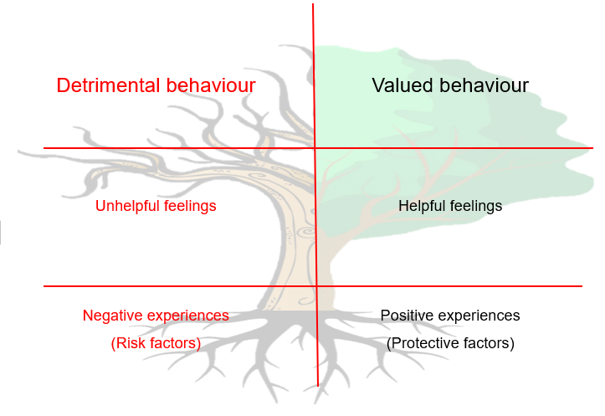

Therapeutic Tree
This is used to ensure:
- We understand experiences where the child will need support
- We understand positive experiences the child needs
- We acknowledge the therapeutic component of the child’s needs – what the individual needs to feel before they can progress
Checklist:
- Have we acknowledged the child’s behaviour may be rooted in current experiences, but also in experiences based in the past? (trauma, ACEs, attachment, mental health and well-being)
- Have we acknowledged the child’s behaviour may be rooted in current feelings and acknowledged that these may not be logical to others?
- Are the detrimental behaviours described factually and unemotionally?
- Are the child’s current valued behaviours acknowledged and analysed?
- Are the valued behaviours we are aiming to create small, measurable, achievable and realistic?
- Have we acknowledged successful strategies already in place?
- Will any listed positive experiences predictably create more helpful feelings?

Appendix 2 – Inclusion Circles

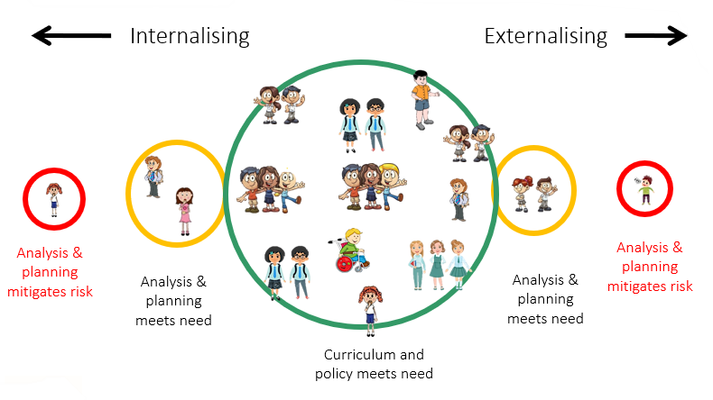

This image identifies the need to differentiate for different groups and individual children. It helps us to consider whether we need to manage behaviour through adaptation or risk of harm through protective consequences.

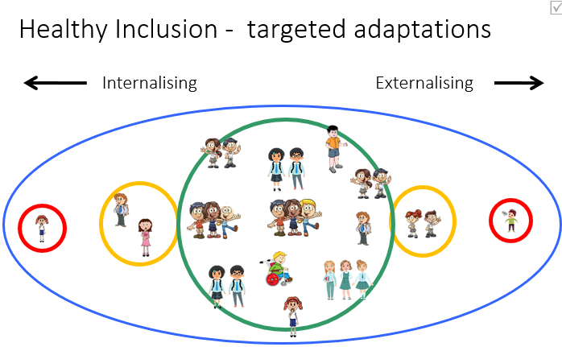

Appendix 3a – Golden Rules

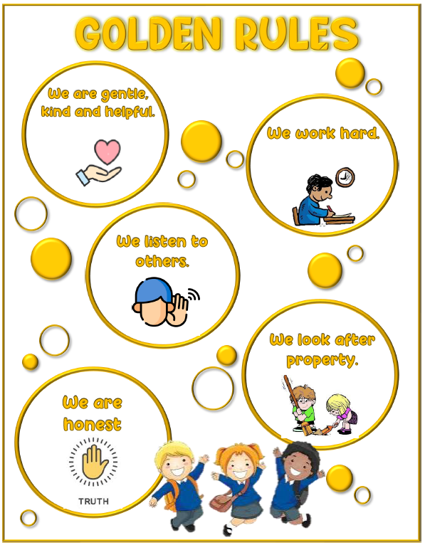
Appendix 3b – Whoops Poster
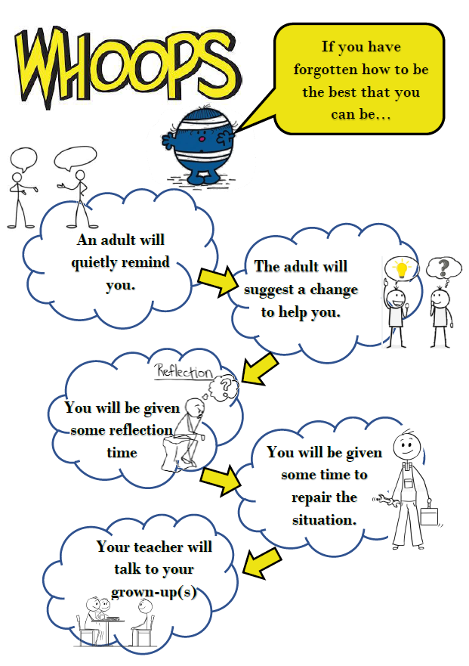

Appendix 4 – Graduated Response
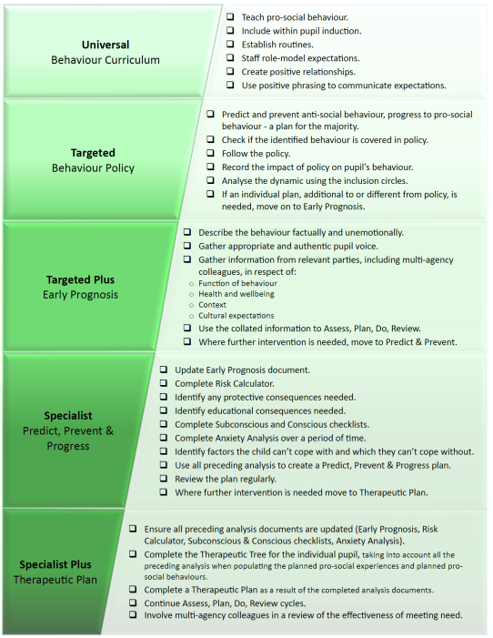

Appendix 5 – Behaviour management flow-chart
 | Examples of inappropriate Behaviour | Action Needed / Consequences | Recording & Communication
Level 1 - Universal | - Not listening / ignoring instructions  - Fidgeting / rocking on chair  - Pushing in line  - Talking out of turn  - Distracting / disturbing others / chatting  - Unkind language / treatment of others  - Off task  - Wandering  - Not looking after own / others’ / school’s property Inappropriate responses e.g. shrug | Promote and reward valued behaviour  If necessary, select an educational or protective consequence:  - Use of planned scripts, offering limiting choice ‘either…or…’  - Offer an appropriate consequence ‘if you continue to…. then…’ | Class teacher / member of staff involved to make a personal note of the behaviour in order to later identify any patterns or links within a bigger picture.
Level 2 - Targeted | - Repeated incidence of Level 1 behaviour in the same session  - Reluctance to follow instructions (refusal / defiance)  - Swearing / inappropriate language  - Non-compliance with class expectations  - Deliberate disruption of lesson  - Telling lies  - Spitting, e.g. on the floor | Promote and reward valued behaviour  If necessary, select an educational or protective consequence:  - Use of planned scripts, offering limiting choice ‘either…or…’  - Offer an appropriate consequence ‘if you continue to…. then…’  - After the incident, use Reflection sheet once they are back in the Green Zone | Class Teacher / member of staff involved to log incident on CPOMs on the day the behaviour occurred, including a scanned copy of the Reflection activity (age appropriate – adult led / independent).  Conversation between Class Teacher and Parent / Carer
Level 3 – Targeted Plus | - Repeated incidence of Level 2 behaviour in the same half-term  - Severe disruption - lesson can’t continue  - More serious challenges to authority  - Minor vandalism to school or personal property  - Any form of physical or verbal retaliation  - Kicking, biting, punching, spitting (at another), fighting  - Swearing or persistent rudeness  - Racial, homophobic, sexist, LGBTQ+ based, disability based, religious based or any other form of prejudiced language  *these apply whether the child has instigated the incident or is acting in retaliation  * repetitive Level 3 behaviours will result in Level 4 consequences | Promote and reward valued behaviour  If necessary, select an educational or protective consequence:  - Use of planned scripts, offering limiting choice ‘either…or…’  - Offer an appropriate consequence ‘if you continue to…. then…’  - Reflective time out of class  - Loss of activity, responsibility or privileges  - Relevant intervention /support – consideration of pastoral / SEND route  *child must be debriefed by the class teacher about the behaviour at the next appropriate time and given the opportunity to complete the Reflection sheet once they are back in the Green Zone. | Class Teacher / member of staff involved to log incident on CPOMs on the day the behaviour occurred, including a scanned copy of the Reflection activity (age appropriate – adult led / independent).  Formal meeting with parent / carer.
Level 4 - Specialist | - Pre-meditated or unprovoked violent behaviour  - Persistent disruptive behaviour  - Verbal abuse of staff and ‘lashing out’  - Swearing intended to deliberately cause offence  - Leaving class without permission  - Theft of others’ property  - Serious or repeated vandalism  - Continuation of bullying | Promote and reward valued behaviour  If necessary, select an educational or protective consequence:  - Further loss of privileges  - Exclusion from forthcoming events  - Internal suspension  - Possible fixed-term suspension  - Pastoral Support Programme  - Use Behaviour Analysis Tool to support teacher and pupil  *child must be debriefed by the class teacher about the behaviour at the next appropriate time and given the opportunity to complete the Reflection sheet once they are back in the Green Zone. | Class Teacher / member of staff involved to log incident on CPOMs on the day the behaviour occurred, including a scanned copy of the Reflection activity (age appropriate – adult led / independent).  Chair of Governors notified if suspension applies.  Meeting with parents and further meetings arranged to review behaviour  Letter to parents if suspension applies  AHT (Inclusion) to seek advice from external agencies  Local authority informed of suspension
Level 5 – Specialist Plus | - Serious physical/emotional assault to anyone in the school community  - Serious damage to school or personal property  - Continuous breaches of behaviour policy despite intervention involving staff, AHT/DHT/HT and parents  - Any other serious incident or illegal activity that jeopardises the wellbeing and safety of anyone within the school community e.g. possession/use of bladed item, drugs, firearm etc.  *This list is for illustrative purposes and is not exhaustive | Where any of the above has not had an impact over time or for an isolated serious incident, the following procedures should be followed:  - Isolation within school on a 1:1 basis with the AHT/DHT/HT  Follow Luton Suspensions and Exclusions Guidance  - Suspension – fixed term  *The length of suspension will be determined by the severity and/or frequency of the circumstances. Repeated suspensions will increase in length as part of the escalation process.  - Exploration of reduced timetable/managed move/alternative provision  - Exclusion – permanent | HT to manage via appropriate sanctions including fixed term suspension or permanent exclusion.  Log incident on CPOMs on the day the behaviour has occurred.  Parents informed immediately.  Chair of Governors notified.  Police, as appropriate.  Local authority informed of exclusion.  Meeting with parents followed by a formal letter.

Appendix 6 – Examples of Protective and Educational Consequences

As a logical consequence for behaviours that do not meet the school’s behaviour expectations, educational and / or protective consequences may be put in place to make support children in making behaviour changes.

Protective Consequences:
These are used when children display dangerous detrimental behaviours. Some examples of protective consequences are:
- Temporarily increased adult ratios
- Limited access to outside space
- Escorted in social situations
- Restricted offsite activities
- Differentiated teaching spaces
- Differentiated curriculum or resources

Educational Consequences:
It is essential that there is always an element of restorative practice. We must be able to show how we have helped the child develop new skills or ways of thinking through discussion, debrief activities or rehearsing. Restorative practices provide the student with the skills and incentives to behave differently when faced with a similar set of circumstances. Some examples of educational consequences are:
- Learning about the relevance of the task
- Rehearsing and practising behaviour
- Understanding and assisting with repairs
- Researching the implications of behaviour
- Conversation and exploration (developing tolerance, empathy and understanding)

Detrimental Behaviour | Appropriate Educational Consequence | Appropriate Protective Consequence | Further Guidance
Absconding:  not where they should be at the right time, e.g. running off at lining up time | Restorative de-brief to include:  - Look at the valued behaviours in the class charter  - Social story  - Complete appropriate Reflection Activity  - Practise of key skills, e.g. lining up, stopping when the bell rings etc.  - Praise of valued behaviour | Leave the playground with supervision before the bell rings  Adaptation to the routine, e.g. holds fire register, carries water bottles | Do not chase. One member of staff needs to be allocated to ensure child is safe (detrimental behaviour is tactically ignored).  Children who have been identified as being at risk of displaying this behaviour should always be closely monitored and supported to enable staff to intervene before they escalate.
Persistent Swearing | Restorative de-brief to include:  - Look at the valued behaviours in the class charter and Golden Rule “We are kind and helpful”.  - Discussion with the child about helpful and unhelpful feelings?  - Social Story  - Complete appropriate Reflection Activity  - Praise of valued behaviours | Swearing which is targeted and aggressive towards individuals or groups mat result in the child having social interactions limited for a set time.  In some instances, it may be necessary for the other children present to be removed from the situation. | Staff must not react but instead stay calm.  Use de-escalation script: “I can see you are upset, I am here to help…”  Children who have been identified as being at risk of displaying this behaviour should always be closely monitored and supported to enable staff to intervene before they escalate.
Physical Altercation  e.g. hitting, pinching, scratching, punching, kicking, strangling, hair pulling and aggressive pushing) | Restorative de-brief to include:  - Look at the valued behaviours in the class charter and Golden Rules “We are kind and helpful” and “We are gentle”  - Social Story  - Support the child in thinking about how they can repair the relationship. Within this explore how everyone involved feels – are these helpful or unhelpful feelings?  - Complete appropriate Reflection Activity  - Consider pre-emptive strategies when faced with a similar situation  - Praise of valued behaviours | Aggression, which is targeted towards individuals or groups may result in the child having social interactions limited for a set time.  In some instances, it may be necessary for the other children present to be removed from the situation. | Staff must not react but instead stay calm.  Use de-escalation script: “I can see you are upset, I am here to help…”  Children who have been identified as being at risk of displaying this behaviour should always be closely monitored and supported to enable staff to intervene before they escalate.
Spitting | Restorative de-brief to include:  - Look at the valued behaviours in the class charter and Golden Rules “We are kind and helpful” and “We are gentle”  - Child to clean the spit up  - Social Story to understand hygiene and offence caused  - Support the child in thinking about how they can repair the relationship. Within this, explore how everyone involved feels – are these helpful or unhelpful feelings?  - Complete appropriate Reflection Activity  - Consider pre-emptive strategies when faced with a similar situation  - Praise of valued behaviours | Spitting which is targeted may result in the child having social interactions limited for a set time.  In some instances, it may be necessary for the other children present to be removed from the situation. | Staff must not react but instead stay calm.  Use de-escalation script: “I can see you are upset, I am here to help…”  Children who have been identified as being at risk of displaying this behaviour should always be closely monitored and supported to enable staff to intervene before they escalate.
Throwing furniture (and implements that can cause harm) | Restorative de-brief to include:  - Look at the valued behaviours in the class charter and Golden Rules “We look after property”  - Social Story  - Support the child in thinking about how to repair the relationship if damaged. Within this, explore how everyone involved feels – are these helpful or unhelpful feelings?  - Complete appropriate Reflection Activity  - Consider pre-emptive strategies when faced with a similar situation  - Praise of valued behaviours | Immediate removal of other children may be necessary.  Certain resources may be restricted for a set period of time and gradually returned, e.g. scissors, science equipment, PE equipment and other resources.  Adaptations to classroom set up, revision of seating plan and access to activities may need to be limited | Staff must not react but instead stay calm.  Use de-escalation script: “I can see you are upset, I am here to help…”  Children who have been identified as being at risk of displaying this behaviour should always be closely monitored and supported to enable staff to intervene before they escalate.
Damage to Property | Restorative de-brief to include:  - Look at the valued behaviours in the class charter and Golden Rules “We look after property”  - Social Story  - Support the child in thinking about how they can repair the damage to property and / or relationships. Within this, explore how everyone involved feels – are these helpful or unhelpful feelings?  - Complete appropriate Reflection Activity  - Consider pre-emptive strategies when faced with a similar situation  - Child to pick up items that have been thrown  - Praise of valued behaviours | Immediate removal of other children may be necessary.  Adaptations to classroom set up, revision of seating plan and access to activities may need to be limited  Some time working away from the main class may be necessary until the child is able to display ‘safe’ behaviour. | Staff must not react but instead stay calm.  Use de-escalation script: “I can see you are upset, I am here to help…”  Children who have been identified as being at risk of displaying this behaviour should always be closely monitored and supported to enable staff to intervene before they escalate.
Defiant Refusal | Restorative de-brief to include:  - Exploration of why the child does not want to complete the work. Do they understand? Does it need adaptations?  - Exploration of the feelings of all those involved, the Class Charter and Golden Rule “We work hard”  - Complete the work at a different time  - Practise alternative strategies when in a similar situation |  | Use of scripts and limited choice, “We can complete the work now or when you are ready, but it does need to be completed.”  Praise valued behaviour as soon as observed.
Persistent Disruptive Behaviour | Restorative de-brief to include:  - Exploration of why the child is disrupting the learning. Do they understand? Does the work need adaptations? Do they need more challenge?  - Exploration of the feelings of all those involved, the Class Charter and the Golden Rules “We are kind and helpful”, “We work hard”  - Practise of alternative strategies when in a similar situation.  - Rehearsing and practising behaviour expectations until secure | Adaptations to classroom set up, seating plans and access to activities may need to be limited.  Some time working away from the main class may be necessary until the child is able to demonstrate positive, valued behaviours. | Praise valued behaviour as soon as observed.

Appendix 7 – Scripts

Unsocial Behaviours – Use ‘thank you’ not ‘please’
Behaviour | Positive Phrasing | Limited Choice | Disempowering the behaviour and / or de-escalation | Protective or Educational Consequence
Leaving their seat without permission. | ‘Stay seated on your chair (name).’  ‘Who else can I see sitting well at their table?’ | ‘Are you going to sit on your own or with the group?’ (repeat)  ‘Would you like to sit on the chair at this table or this one?’ (repeat) | ‘You can still listen to the instructions / story from there.’ | ‘We will check you understand how to…...before you go out to break.’
Leaving the carpet during input / story without permission. | ‘I can see you may not be comfortable there but stay seated until we have finished.’ | ‘Would you like to sit in your carpet space / at your table, or next to me?’ (repeat) | ‘You can still listen to the instructions / story from there.’ | ‘We will check you understand how to…...before you go out to break.’
Refusing to complete the work set. | ‘I know you want to do…..First I need you to……, then you can……’  Can you tell me…… / show me……?’ | ‘I can see you are not ready to do Maths now, so we can spend 5 minutes now (alt activity) …and come back to Maths when you are ready.’  ‘I wonder if we will be faster at the……table?’ (repeat)  Are you starting your work with the words or a picture?’ (repeat)  ‘You can work with a friend or on your own.’ (repeat) | ‘You can choose to finish it later.’ | Rehearsing and practising.  Completing tasks.  Differentiated curriculum – possibly practical and creative activities to encourage engagement in class.
Refusal to do PE. | ‘I can see you are not ready to join in with PE now so you can join in the middle bit or the end.’ (repeat) | ‘Would you like to keep score or help me give out equipment?’ | ‘You can watch if you would like to?’ | ‘At break we will talk about the bits you find difficult in PE.’
Not listening to / not following instructions. | ‘I can see you are not choosing to listen at the moment, would you like me to explain again after the lesson?’  ‘Well done everyone for stopping (in PE) when asked as that is the safe way to do PE.’  ‘Fantastic listening from……I like the way you are staying still and looking at me so you can follow my instructions.’ |  | ‘You can choose to have another go later.’ | ‘We will check you understand how to……at break.’
Choosing to do another activity than the one the class are doing (reading / drawing on whiteboard etc.) | ‘I can see you are choosing to……now rather than join in. If you do this first, then you can……after that.’ | ‘You can choose to do this now or later.’ (repeat) | ‘You can choose to do this later if you would like when the others are doing……’ | ‘We can check you understand what to do at break.’
Rocking on their chair | ‘Put the 4 chair legs on the floor.’ | ‘Do you want to sit on the chair or the carpet?’ (repeat) |  | ‘We may need to practise how to sit on the chair safely at breaktime.’
Calling out / talking to a friend. | ‘We are taking it in turns to listen. Who else can I see listening carefully?’  ‘I can see you are not choosing to listen at the moment. Would you like me to explain again after the lesson?’ |  |  | ‘We can check you understand what to do before you go out to break.’
*Playing / fidlding with equipment.  (N.B. Some children may need to do this when listening – if they are not disrupting others. They may need to be given a specific fiddle toy) | ‘I can see you want to fiddle with the…… When we are listening – it may be distracting others.’  ‘Put the …… on the table’ | ‘Put it on your table or give it to me’ (repeat) |  | ‘We can find a special place to keep your …… at break and check you understand what to do.’
*Not sitting ‘appropriately’ for learning  (N.B. Carpet time is difficult for some children. Some may find it very difficult to sit still and cross-legged on the carpet or up straight on a chair. Try and offer times when they choose their best listening position and offer this on occasion, e.g. storytime) | ‘You need to sit up to your desk for this lesson because……(e,g, it will help your presentation / show me that you have understood the instructions) later for storytime you can……(e.g. sit in your favourite way)

Detrimental Behaviours
For the following behaviours, note the frequency as it is this that normally makes them more intolerable. Only very frequent and persistent examples will require Year or Phase Lead intervention
Continued interruptions | ‘I can see that you are not ready to learn. When you are ready we can talk about the learning at break.’  ‘I can see you are choosing not to listen at the moment. Would you like me to explain again after the lesson?’  ‘I can see you know the answer but at the moment it’s ……’s turn to share their thoughts. | ‘We can talk about ensuring others are able to learn when you are ready. Who would you like to talk to? Me or……? (repeat) | If the interruptions are ‘valid’ and the pupil is keen to get their point across, ensure they understand the ‘rules’ of conversation.  If it is being done purely to disrupt others then use the positive phrasing and choices.  Alternatively, ignore and speak later to individuals. | Conversation and exploration.  Restorative de-brief and reflection.
Aggressive shouting / calling out disruptively
Answering back / mimicking
Swearing | ‘I can see that you are not happy at the moment.’  ‘I can see you are upset’  ‘We can talk when you are ready and when I am ready’ | ‘When you are ready we can talk here or in the…….’ (repeat) ‘ We will carry on when you are ready.’  ‘We can talk when you are ready. Who would you like to talk to? Me or…...?’ (repeat when calm) | ‘I can see you are not happy at the moment. When you are ready to speak to me properly I will listen.’ (then ignore until they are ready) | Conversation and exploration.  ‘Thank you for telling / showing me how you are feeling. If you tell me more, I can listen / help.’
Name calling
Lying
Refusal to carry out an adult’s request | ‘Put the pen on the table.’  ‘I can see you are not ready to do this right now.’  ‘I can see something is wrong. If you want to talk, I will listen – I am here to help.’ | ‘Walk with me to the…… or the……(repeat) |  | Rehearsing and practising.  Restorative de-brief and reflection.  Completing tasks
Distracting and / or disrupting others’ learning by shouting, banging, making noises. | ‘I can see that you are not happy at the moment and you are not ready to learn / play.’ | ‘When you are ready, we can talk here or in the ……’ (repeat)
Leaving the classroom without permission | ‘I can see that you are not happy at the moment.’ | ‘Come back in to the room when you are ready and we can talk here or with……Who would you like to talk to? Me or……? (repeat)  ‘You can come and find me when you are ready.’ | ‘I can see you are not happy at the moment. When you are ready to come back to class, I will listen.’ (then ignore until they are ready as long as another adult is in the vicinity) | Educational opportunities – identify early warning signs for needing to leave.  Create a ‘safe space’ in the classroom if staying in class is difficult.  Rehearsing and practising.  Restorative de-brief and reflection.  Completing tasks
Damage to property | ‘I can see that you are not happy at the moment.’ | ‘When you are ready, we can talk here or in the ……’ (repeat) |  | Restorative de-brief and reflection.  Assisting with repairs or planning these.
Stealing | ‘I can see that you have taken something that doesn’t belong to you.’ | ‘When you are ready to return it, you can give it to me or…..’ (repeat) |  | Restorative de-brief and reflection.  Educational opportunity – research the real-world implications.

Detrimental Dangerous Behaviours – will likely need SLT support after following the script.
Behaviour | Positive Phrasing – Can include distracting / rephrasing | Limited Choice | Disempowering the behaviour and / or de-escalation | Protective or Educational Consequence
Leaving the school building  Leaving the premises | ‘I am not chasing you. I’ll be standing here to make sure you are safe. When you go to (adult) inside, we can solve the problem.’  ‘(Name) you have left the school premises so I am calling the police.’ | ‘I can see there is something wrong. Do you want to come inside and talk to Mr/Mrs…… or Mr/Mrs….. (give a choice of 2 – whichever are the most appropriate / available) |  | Conversation and exploration  Restorative debrief and reflection  Consider limit to outside space.  Escorted in social situations / breaktimes  Restricted off-site activities
Spitting (directly at another)  Hitting  Kicking  Fighting  Biting  Punching  Throwing furniture  Hair pulling  Pushing aggressively  Scratching  Pinching | ‘’Your actions have hurt me / (child’s name). Use your words and I will listen.’ | ‘I can see there is something wrong. Do you want to come inside and talk to Mr/Mrs…… or Mr/Mrs….. (give a choice of 2 – whichever are the most appropriate / available)  If already inside, the choice would be to come and talk to one of these adults and away from where they are at that moment. | ‘(Child’ name), I can see something has happened.’  ‘I am here to help’  ‘Talk and I will llisten.’  ‘Come with me and…’ | Protective Consequences  Possible limit to outside space  Escorted in social situations / breaktimes  Restricted off-site activities  Differentiated teaching space  Suspension / Exclusion  Restorative de-brief including apology to those affected and reflection.

Post incident recovery and debrief measures (Restorative Practice)
- ‘It is time for a chill and a chat.’
- ‘Tell me what happened when……’
- ‘How were you feeling when you……? Who has been affected?’
- ‘How can you help put this right?’
- So let’s practise what we have learned so we can do things better next time.’

Don’t ask too many questions as this will be overwhelming. Maybe start with one or two or say ‘Tell me about….’
One lead member of staff to speak.

Use activities such as: Comic strip conversations, feelings cards, puppets, symbols, small world characters, Reflection sheets (if child is able to access these) (Appendix 6)
All detrimental and detrimental dangerous behaviours need time, patience and praise when the child then shows valued behaviours following any incident.
Examples of responses:
- (Name) you have used your safe space, well done.’
- (Name), you are making a good effort with your learning.’
- ‘Thank you for telling me how this made you feel.’
- ‘Thank you for being honest with me and telling me the truth.’
- ‘I can see that you are upset.’ / ‘Your body language is telling me you are cross.’ / ‘I can understand how that could be upsetting / annoying.’

The above is a guide and staff will need to consider the child’s context, age and any additional needs when determining the course of action.
Staff will ensure that a child is not repeating their story unnecessarily and that all parties have had an opportunity to share their version of events.

NB: Suspensions may be implemented in isolated incidents that result in harm to children, staff or damage to property where an investigation has led to a serious breach of the school rules. This is decided on a case by case basis by the Head Teacher

Appendix 8a – Reflection Activity (Child Independent)

My Reflections
Remember – You Own Your Own Behaviour
What happened?
How were people feeling at the time?
Who has been affected? How?
What have you learned from this?
Name: Date:

Remember to write neatly and in full sentences. Explain yourself clearly.

Appendix 8b – Reflection Activity (Adult Led)

Reflect – Repair - Restore
Remember – You Own Your Own Behaviour
What happened? (Explore to discover roots)
How were people thinking / feeling at the time?
Who has been affected? How?
*ensure child knows reality but is not made to feel guilty
How can we repair the relationship/s?
Summarise:
Were parents informed? |  | Y | N
If no, what was the reason?
1st Incident | Ongoing Concern

Appendix 9 – Behaviour Support Plan

Add picture of child’s choice here to personalise | Behaviour Support Plan  ‘You Own Your Own Behaviour’ |  |  |  | 
Name: Class: Day/Date:
Ticks:  0 – not met  1 – partially met  2 – met | Target 1 | Target 2 |  | Target 3 | Total
1st Session
Breaktime
2nd Session
Lunchtime
3rd Session
4th Session
Target for today:  Maximum: |  |  | Today’s overall total:
Comments: for parents, children and staff contribution



