Putteridge Primary
School


Relationships, Health & Sex Education Policy 2026

Aims
The aims of Relationships, Health and Sex Education (RSHE) at our school are to:
- Provide a framework in which sensitive discussions can take place
- Prepare pupils for puberty, and give them an understanding of sexual development and the importance of health and hygiene
- Help pupils develop feelings of self-respect, confidence and empathy, and cultivate positive characteristics such as kindness and integrity
- Create a positive culture around issues of sexuality and relationships
- Teach pupils the correct vocabulary to describe themselves and their bodies

Statutory requirements
As a maintained primary school, we must provide relationships education to all pupils under section 34 of the Children and Social Work Act 2017.
We are not required to provide sex education, but we do need to teach the elements of sex education contained in the science curriculum.
In teaching RSHE, we must have regard to guidance issued by the secretary of state, as outlined in section 403 of the Education Act 1996.
We also have regard to legal duties set out in:
- Sections 404 to 407 of the Education Act 1996.
- Part 6, chapter 1 of the Equality Act 2010
- The Public Sector Equality Duty (PSED) (as set out in section 149 of the Equality Act 2010). This duty requires public bodies to have due regard to the need to eliminate discrimination, advance equality of opportunity and foster good relations between different people when carrying out their activities
At Putteridge Primary School, we teach RSHE as set out in this policy.

Definition
For the purpose of this policy:
RSHE in this school is about the emotional, social and cultural development of pupils, and involves:
- providing the knowledge and information to which all pupils are entitled;
- helping children to develop feelings of self-respect, self-esteem, self -confidence, sympathy and empathy;
- providing the confidence to be participating members of society and to value themselves and others;
- preparing pupils for puberty and encourage them to take responsibility for their own actions;
- giving pupils an understanding of reproduction and sexual development;
- giving pupils an understanding of the importance of health and hygiene.
- developing and using communication skills and assertiveness skills to cope with the influences of their peers and the media;
- developing pupil understanding of respecting and caring for their bodies;
- giving pupils information on where individuals and families can get help and support.

RSHE involves a combination of sharing information, and exploring issues and values.
RSHE is not about the promotion of sexual activity.

Curriculum
Our RSHE curriculum is set out as per Appendices 1 and 2, following the Christopher Winter programme, as advocated by Luton Borough Council.
We have developed the curriculum taking into account the age, developmental stage, and needs of our pupils. If pupils ask questions outside the scope of this policy, teachers will respond in an appropriate manner and may direct pupils to refer their question(s) to their parents as necessary.
We will share all curriculum materials with parents and carers upon request.

Delivery of RSHE
RSHE is taught within the Personal, Social, Health and Economic (PSHE) education curriculum.
The school will ensure that:
- Core knowledge is sectioned into units of manageable size
- The required content is communicated to pupils clearly, in a carefully sequenced way and within a planned scheme of work
- Teaching includes sufficient and well-chosen opportunities and contexts for pupils to embed new knowledge, so that it can be used confidently in real-life situations

Relationships Education focuses on teaching the fundamental building blocks and characteristics of positive relationships including:
- Families and people who care for me
- Caring friendships
- Respectful, kind relationships
- Online safety and awareness
- Being safe

Primary Sex Education will focus on:
- Preparing boys and girls for the changes that adolescence brings
- How a baby is conceived and born

Teachers will make sure that all pupils’ views are listened to, and will encourage them to ask questions and engage in discussion. Teachers will answer questions sensitively, honestly and appropriately for the age of the pupils.
The programme is designed to focus on boys as much as girls, and activities are planned to make sure both are actively involved.
The school will make sure that all teaching and materials are appropriate for the ages and needs of the pupils including any additional needs, such as special educational needs and disabilities (SEND).
For more information about our RSHE curriculum, see Appendices 1 and 2.
We may amend our curriculum content to respond to the needs and context of our pupils, to discuss issues affecting them in an age-appropriate manner. We will inform parents and carers of any deviation from our published policy in advance, and share any relevant materials on request.
These areas of learning are taught within the context of family life, taking care to make sure that there is no stigmatisation of children based on their home circumstances (i.e. families can include single-parent families, same-sex parents, families headed by grandparents, adoptive parents and foster parents among other structures), along with reflecting sensitively that some children may have a different structure of support around them (for example, looked-after children, young carers or kinship carers).
Across our school, we will also be mindful of the law and legal requirements, taking care not to condone or encourage illegal activity, such as violent action against people, criminal damage to property or hate crime.

Inclusivity
We will teach about these topics in a manner that:
- Considers how a diverse range of pupils will relate to them
- Is sensitive to all pupils’ experiences
- During lessons, makes pupils feel safe and supported and able to engage with the key messages

For the two lessons in Year 6 that cover elements of Sex Education, classes may be split so that the boys and girls are taught separately.

Use of resources
We will ensure that resources we use:
- Are aligned with the teaching requirements set out in the statutory RSE guidance
- Would support pupils in applying their knowledge in different contexts and settings
- Are age-appropriate, given the age and maturity of the pupils
- Are evidence-based and contain robust facts and statistics
- Fit into our curriculum plan
- Are from credible sources
- Are sensitive to pupils’ experiences and won’t provoke distress

Roles and responsibilities

The Governing Body
The Governing Body will approve the RSHE policy, and hold the Headteacher to account for its implementation.

The Headteacher
The Headteacher is responsible for making sure that RSHE is taught consistently across the school, for sharing all resources and materials with parents and carers upon request, and for managing requests to withdraw pupils from non-statutory components of RSHE.

Staff
Staff are responsible for:
- Delivering RSHE in a way that is sensitive, high-quality and appropriate for each year group
- Modelling positive attitudes to RSHE
- Responding to the needs of individual pupils
- Responding appropriately to pupils whose parents/carers wish them to be withdrawn from the non-statutory components of RSE
- Modelling positive behaviour and avoiding language that might perpetuate harmful stereotypes, and being conscious of everyday sexism, misogyny, homophobia and stereotypes
- Reporting any safeguarding concerns or disclosures that pupils may make as a result of the subject content to the school’s Designated Safeguarding Lead, Mrs Vicki Prowle.

Pupils
Pupils are expected to engage fully in RSHE and, when discussing issues related to RSHE, treat others with respect and sensitivity.

Parents’ right to withdraw
Parents/carers do not have the right to withdraw their child from Relationships Education lessons, though they do have the right to withdraw their child from the non-statutory components of Sex Education within RSHE.
The only two lessons that parents/carers can request to withdraw their child are lessons 1 & 3 of the Year 6 scheme of work.
Requests for withdrawal should be put in writing addressed to the Headteacher.
Alternative schoolwork will be given to pupils who are withdrawn from the Sex Education lessons.

Policy reviewing arrangements
This policy will be reviewed on an annual basis by the full Governing Body of Putteridge Primary School.

Ratified: April 2026
Date of review: September 2027

Appendix 1: Curriculum map
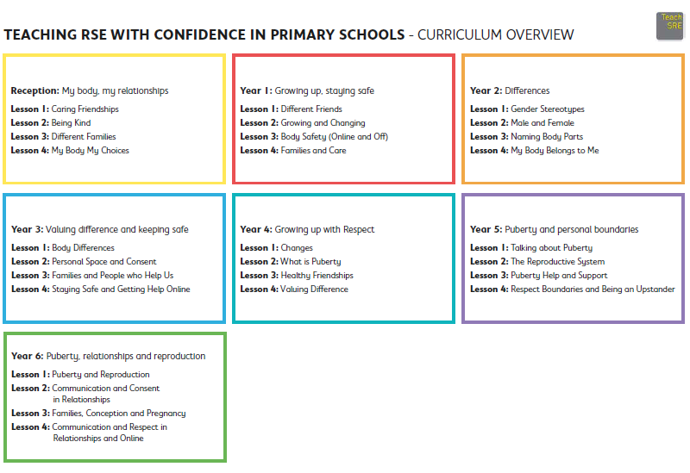
Appendix 2: By the end of primary school pupils should know
Topic | Pupils should know
Families and people who care for me | - That families are important for children growing up because they can give love, security and stability  - The characteristics of safe and happy family life, such as: commitment to each other, including in times of difficulty, protection and care for children and other family members, the importance of spending time together and sharing each other’s lives  - That other children’s families, either in school or in the wider world, sometimes look different from their own, but they should respect those differences and know that other families are also characterised by love and care  - That stable, caring relationships are at the heart of safe and happy families, and are important for children’s security as they grow up  - That marriage and civil partnerships represent a formal and legally recognised commitment of 2 people to each other which is intended to be lifelong  - How to recognise if family relationships are making them feel unhappy or unsafe, and how to seek help or advice from others if needed
Caring friendships | - How important friendships are in making us feel happy and secure, and how people choose and make friends  - The characteristics of friendships that lead to happiness and security, including: mutual respect, truthfulness, trust and trustworthiness, loyalty, kindness, generosity, sharing interests and experiences and support with problems and difficulties  - That healthy, caring and kind friendships are positive and welcoming towards others, and do not make others feel lonely or excluded. Pupils should learn skills for developing caring, kind friendships  - That not every child will have the friends they would like at all times, that most people feel lonely sometimes, and that there is no shame in feeling lonely or talking about it  - That most friendships have ups and downs, and that these can often be worked through so that the friendship is repaired or even strengthened  - About managing conflict with kindness and respect, and that violence is never right  - How to recognise when a friendship is making them feel unhappy or uncomfortable, and how to seek help or advice from others, if needed
Respectful, kind relationships | - The importance of respecting others, including in families and friendships. Pupils should be encouraged to discuss how we can balance the needs and wishes of different people, and why this can be complicated  - The importance of setting and respecting healthy boundaries in all relationships with friends, family, peers and adults  - How to communicate effectively: how to be assertive and express needs and boundaries and manage feelings, including disappointment and frustration  - That they can expect to be treated with respect and the importance of respecting others, including those who are different (for example: physically, in character, personality or background), or make different choices, or have different preferences or beliefs  - The practical steps they can take in a range of different contexts to improve or support their relationships  - The conventions of courtesy and manners  - The importance of self-respect and how this links to their own happiness. They should have opportunities to consider issues like self-esteem and building a sense of their own identity  - Pupils should have opportunities to discuss the difference between being assertive and being controlling, and the difference between being kind to other people and neglecting your own needs.  - About different types of bullying (including cyberbullying), the impact of bullying, responsibilities of bystanders (primarily reporting bullying to an adult) and how to get help  - How to seek help when needed, including when they are concerned about violence, harm, or when they are unsure who to trust  - What a stereotype is, and how stereotypes can be unfair, negative or destructive or lead to bullying and how to challenge a stereotype
Online safety and awareness | - That people sometimes behave differently online, including by pretending to be someone they are not and/or pretending to be a child  - That the same principles apply to online relationships as to face-to face relationships, including the importance of respect for others online including when we are anonymous  - The rules and principles for keeping safe online, how to recognise risks, harmful content and contact, and how to report them  - That there is a minimum age for joining most social media sites which protects children from inappropriate content or unsafe content with older social media users, who may be strangers, including other children and adults  - That it’s important to be cautious about sharing any information about themselves online, and how to use privacy and location settings to protect their information online  - How to critically consider their online friendships and sources of information, including awareness of the risks associated with people they have never met  - How information and data is shared and used online, including where pictures or words might be circulated  - Online risks, including that any material provided online might be circulated, and that once a picture or words has been circulated there is no way of deleting it everywhere and no control over where it ends up  - That the internet contains a lot of content that can be inappropriate and upsetting for children, and where to go for advice and support when they feel worried or concerned about something they have seen or engaged with online
Being safe | - What sorts of boundaries are appropriate in friendships with peers and others (including in a digital context). This can include learning about boundaries in play and in negotiations about space, toys, books, resources for example  - About the concept of privacy and the implications of it for both children and adults, including that it’s not always right to keep secrets if they relate to being safe  - That each person’s body belongs to them, and the differences between appropriate and inappropriate or unsafe physical, and other, contact  - How to respond safely and appropriately to adults they may encounter (in all contexts, including online) including those they do/don’t know  - How to recognise when a relationship is harmful or dangerous, including skills for recognising who to trust and who not to trust  - How to report concerns or abuse, about something seen online or experienced in real life, or feelings of being unsafe or feeling bad about any adult, and the vocabulary and confidence needed to do so  - Where to get advice, for example from their family, school and/or other sources

